# **EV CHARGING STATION MANAGEMENT CRM**

# The electric vehicle (EV) industry is rapidly growing as the world shifts toward sustainable and eco-friendly transportation solutions. With this growth comes the need for efficient management of EV charging infrastructure, customer interactions, and service delivery. A Customer Relationship Management (CRM) system plays a vital role in bridging this gap by ensuring smooth operations, better customer service, and data-driven decision-making.

# Salesforce, being a leading cloud-based CRM platform, provides customizable tools for managing customers, automating processes, and analyzing data. By developing an EV Charging CRM on Salesforce, organizations can manage charging stations, bookings, payments, customer feedback, and maintenance in a streamlined manner. This not only enhances customer experience but also supports business growth through improved operational efficiency and real-time insights.

# **Objectives of the Project**

# Centralized Management – To create a unified platform for managing charging stations, bookings, and customer data.

# Automation of Processes – To reduce manual work by automating workflows such as booking confirmations, payment tracking, and service reminders.

# Data Accuracy & Reporting – To design dashboards and reports for monitoring usage, revenue, and customer behavior for informed decision-making.

# Enhanced Customer Experience – To provide seamless booking, transparent billing, and quick support, thereby increasing customer satisfaction.

# Scalability & Flexibility – To ensure that the CRM can adapt to future requirements like integration with mobile apps, AI-powered recommendations, and new charging models.

# Security & Reliability – To implement data security measures and ensure reliable access to business-critical information.

# Support Sustainable Growth – To contribute towards the adoption of clean energy by making EV charging infrastructure more efficient and accessible.

# **Top of Form**

# **Bottom of Form**

# **EV Charging Station CRM – Phase 1: Problem Understanding & Industry Analysis**

## **1. Requirement Gathering**

To understand the business requirements, discussions would be held with stakeholders such as charging station managers, operators, and customer service representatives.  
  
Example requirements:  
• Track all charging stations and slots with availability status.  
• Allow customers to book charging slots.  
• Prevent overlapping bookings for the same slot.  
• Record payments and generate revenue reports.  
• Log and track breakdowns or maintenance requests.

## **2. Stakeholder Analysis**

• Admin – manages Salesforce setup and configurations.  
• Charging Station Operators – create and manage slot bookings.  
• Manager – approves high-value bookings, monitors reports, and oversees operations.  
• Customer Service – handles issues, cancellations, or breakdown reports.  
• Customers – book slots and make payments (future portal/experience site scope).

## **3. Business Process Mapping**

Flow of the process:  
Customer requests slot → Operator checks availability → Booking created → Approval (if high value) → Payment logged → Confirmation email sent to customer → Breakdowns/issues reported → Service team notified.

## **4. Industry-Specific Use Case Analysis**

In the EV charging industry:  
• Charging slots have limited availability and must be scheduled efficiently.  
• Pricing may vary based on time, location, or type of charger.  
• Breakdowns and maintenance directly affect customer satisfaction.  
• Operators need real-time visibility of utilization and revenue.  
  
Therefore, the CRM must track charging stations, slots, payments, and breakdowns, while automating approvals and customer notifications.

## **5. AppExchange Exploration**

# A review of Salesforce AppExchange shows some energy and asset management apps. However, a dedicated EV Charging CRM is still evolving. This project aims to build a simplified custom solution tailored to charging station operations, helping to streamline workflows, improve customer experience, and prepare the foundation for future integrations (payment gateways, IoT chargers

# **EV Charging Station CRM – Phase 2: Org Setup & Configuration**

The goal of Phase 2 is to set up the Salesforce environment for the EV Charging Station CRM. This includes configuring company settings, defining roles and profiles, setting security policies, and preparing the org for further customization.

## **1. Salesforce Edition**

• Use a Salesforce Developer Edition (free dev org).  
• Sign up at developer.salesforce.com if not already done.

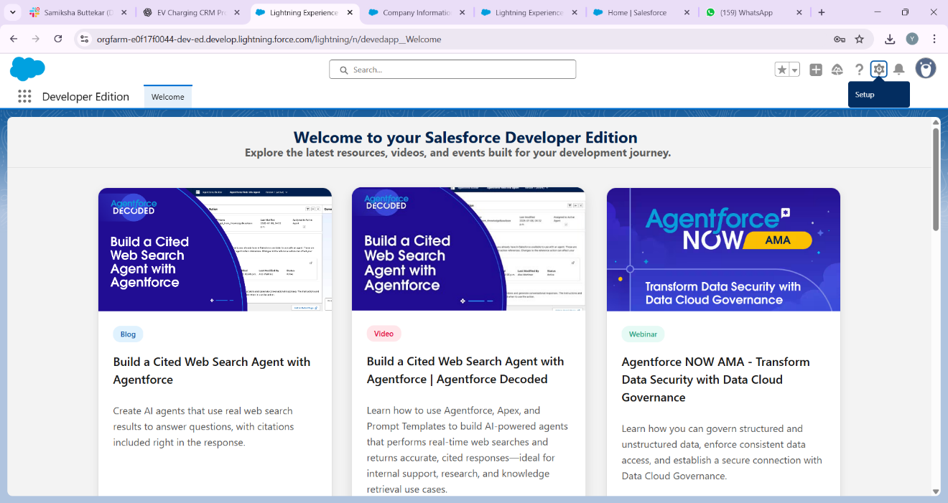

## **2. Company Profile Setup**

• Navigate to Setup → Company Settings → Company Information.  
• Update organization name: 'EV Charging Station CRM'.  
• Set default currency (INR/USD).  
• Configure time zone (IST for India).

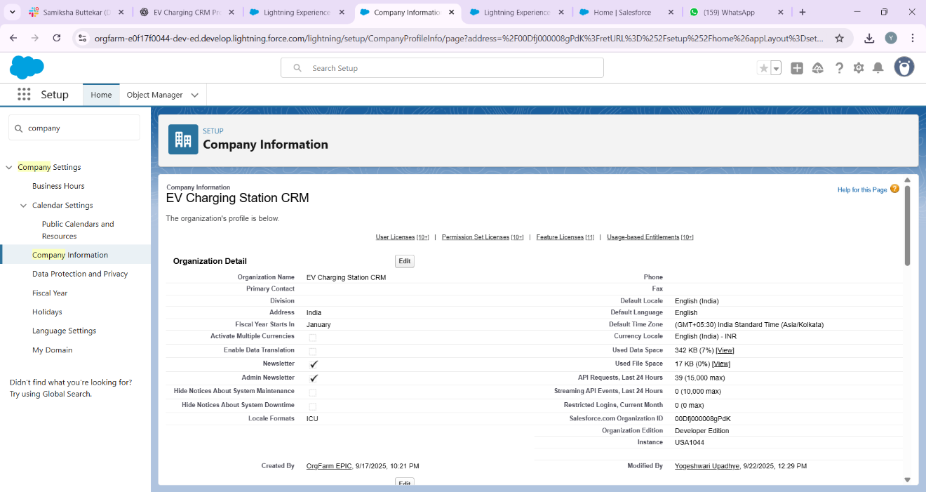

## **3. Business Hours & Holidays**

• Go to Setup → Business Hours.  
• Define working hours (9 AM – 6 PM, Mon–Sat).  
• Add public holidays when approvals/maintenance won’t occur.

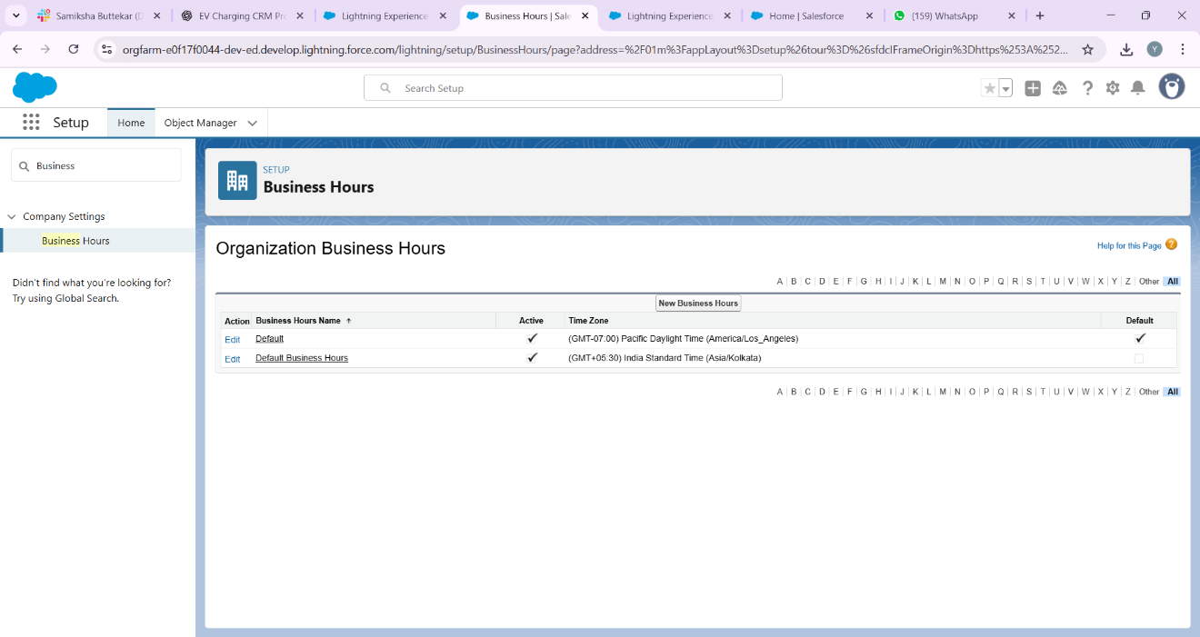

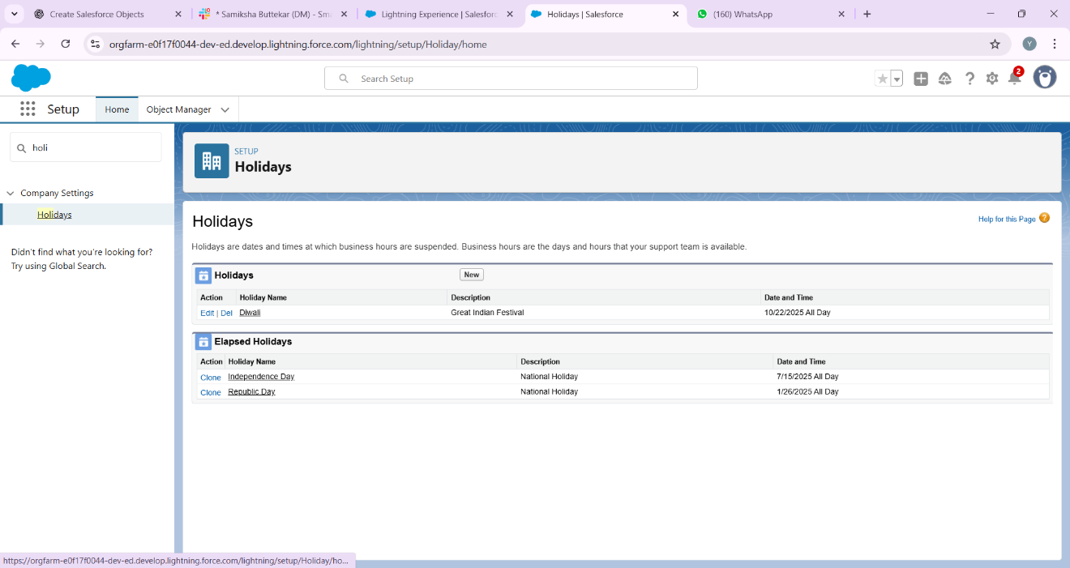

## **4. Fiscal Year Settings**

• Go to Setup → Fiscal Year.  
• Select Standard Fiscal Year (Jan–Dec).  
• This helps in generating accurate revenue and utilization reports.

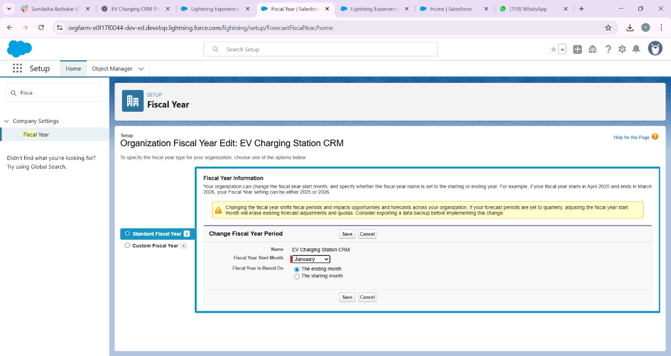

## **5. User Setup & Licenses**

• Create user accounts for:  
 - Charging Station Operator (standard user).  
 - Manager (full access).  
 - Customer Service Agent.  
• Assign appropriate Salesforce licenses.

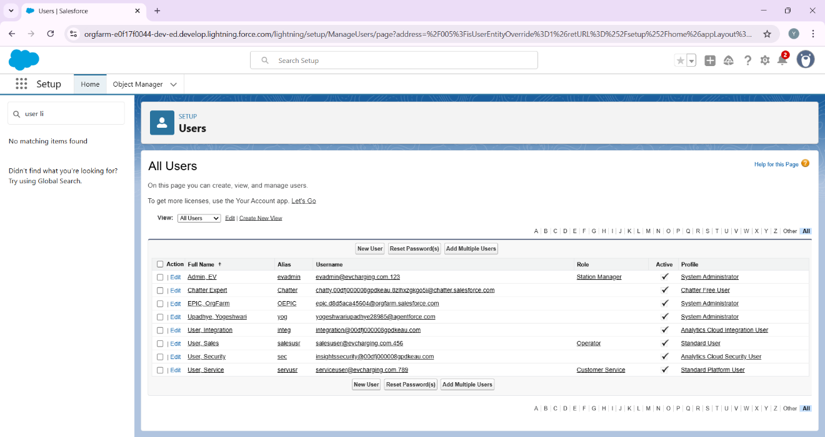

## **6. Profiles**

• Operator Profile: Can create/manage slot bookings.  
• Manager Profile: Full CRUD access across objects.  
• Customer Service Profile: Access to breakdown and payment records.

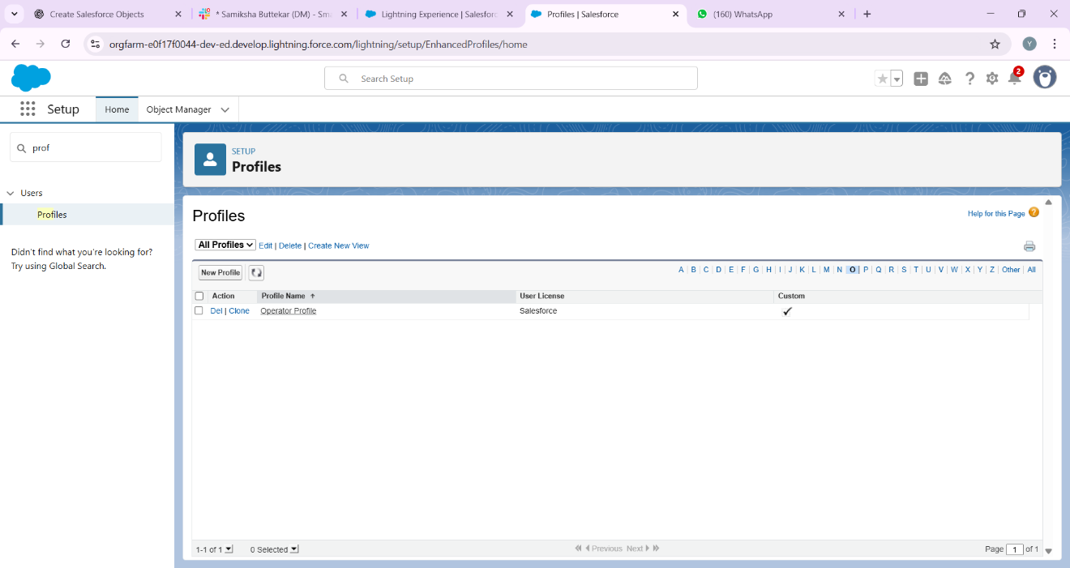

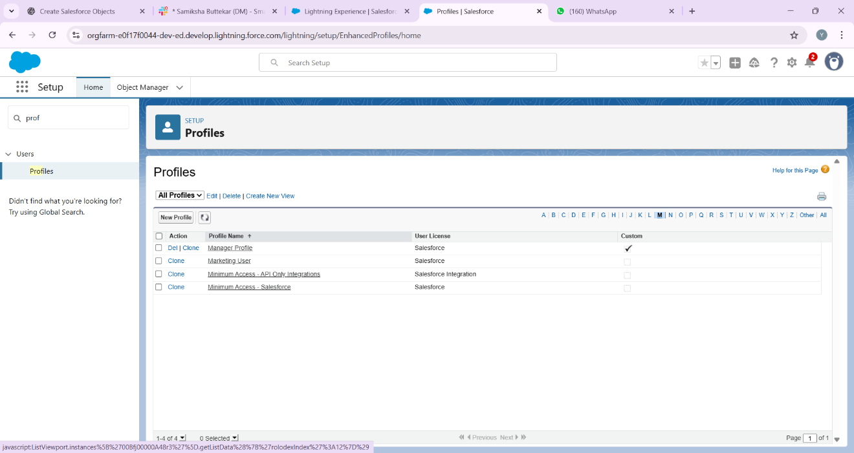

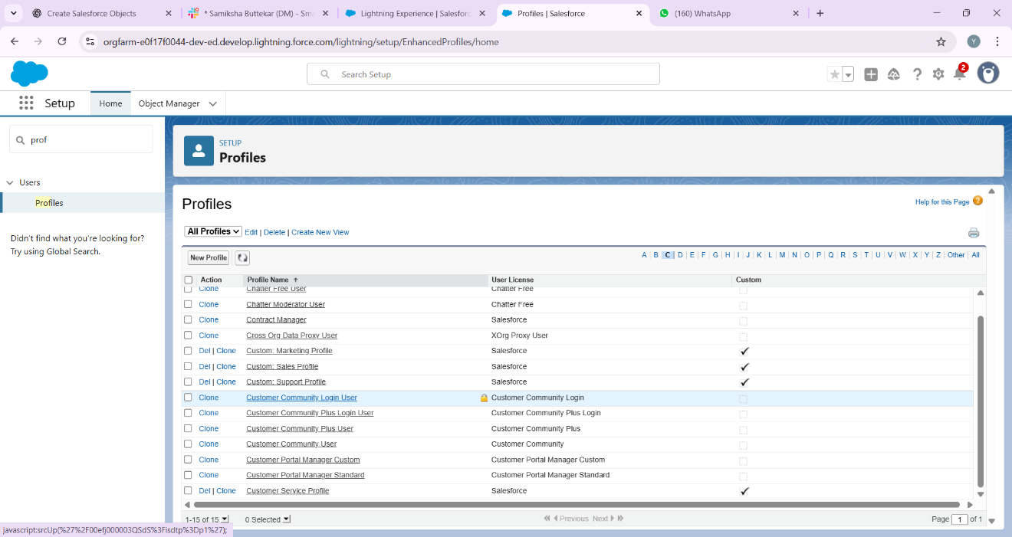

## **7. Roles**

• Create a role hierarchy:  
 - Manager (top).  
 - Operators and Customer Service (below Manager).  
• Ensures that record visibility rolls up to the Manager.

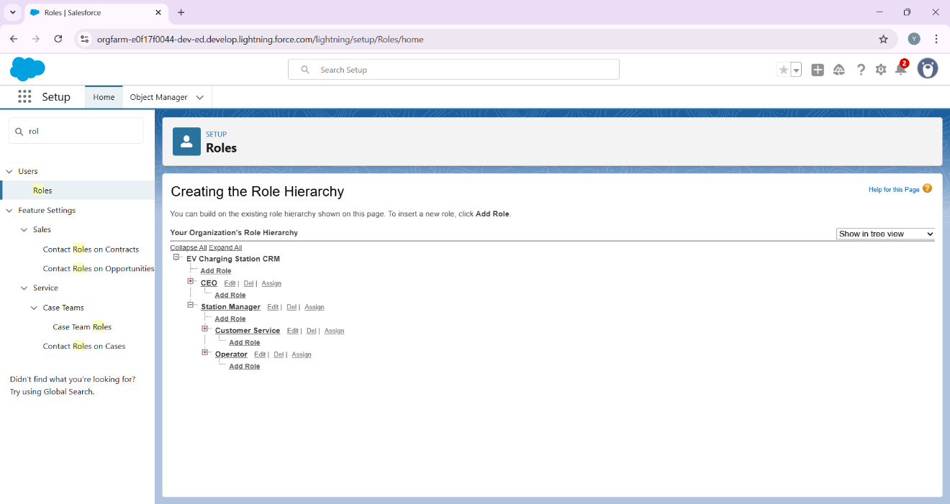

## **8. Permission Sets**

• Create permission sets to grant extra access without modifying profiles.  
• Example: A permission set for 'Report Access' that operators can be assigned.

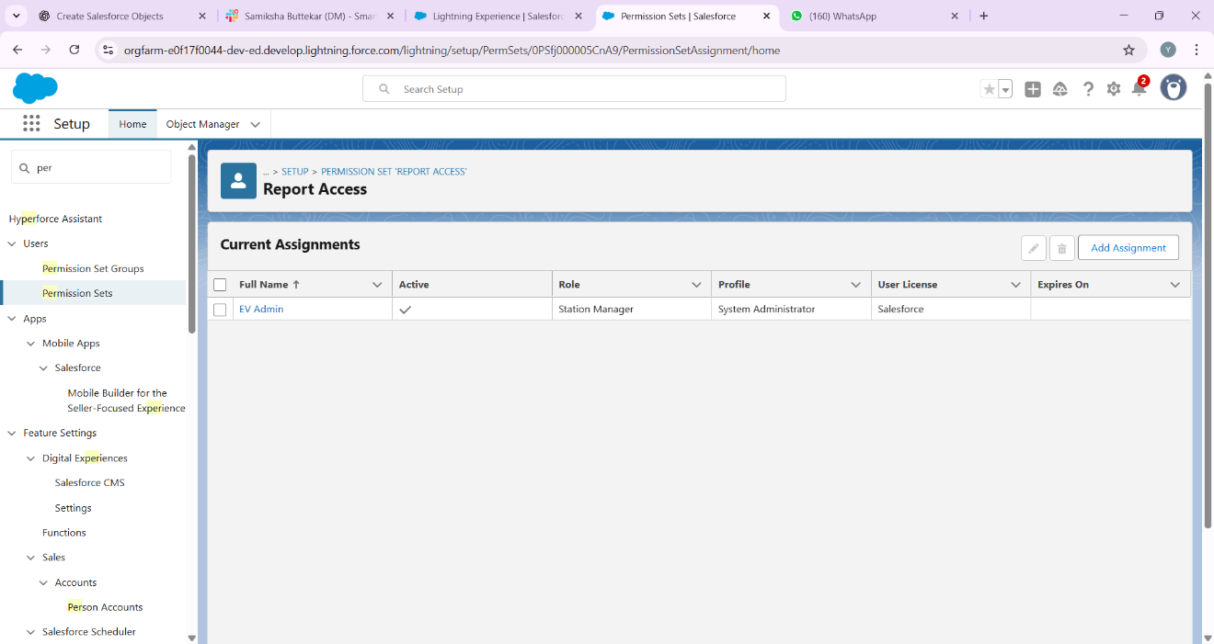

## **9. Org-Wide Defaults (OWD)**

• Charging Station: Public Read Only.  
• Charging Slot: Private (only owner/manager can view).  
• Payment: Private.  
• Breakdown: Controlled by parent (Station/Slot)

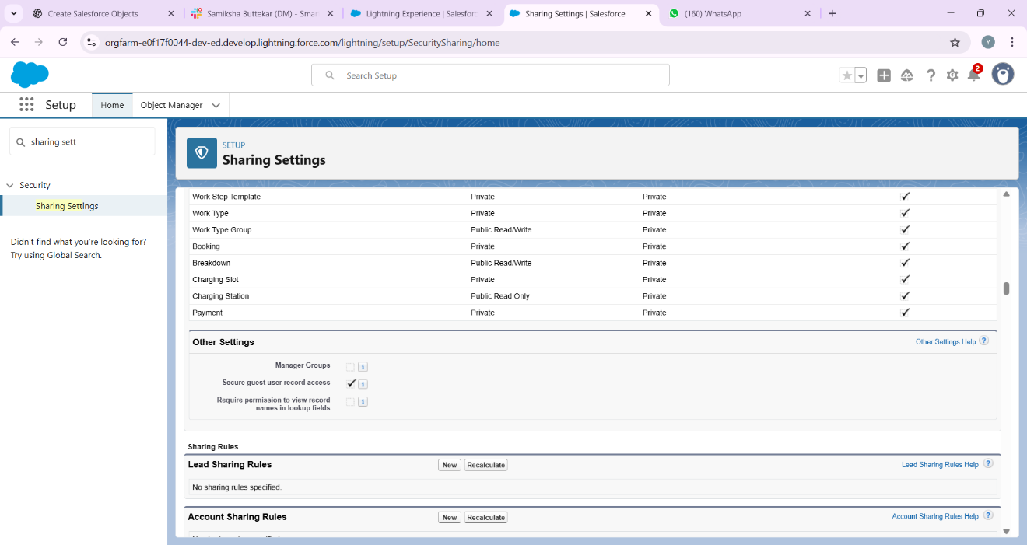

## **10. Sharing Rules**

• Create sharing rules to expand access.  
• Example: Allow all Operators in a region to see each other’s bookings.

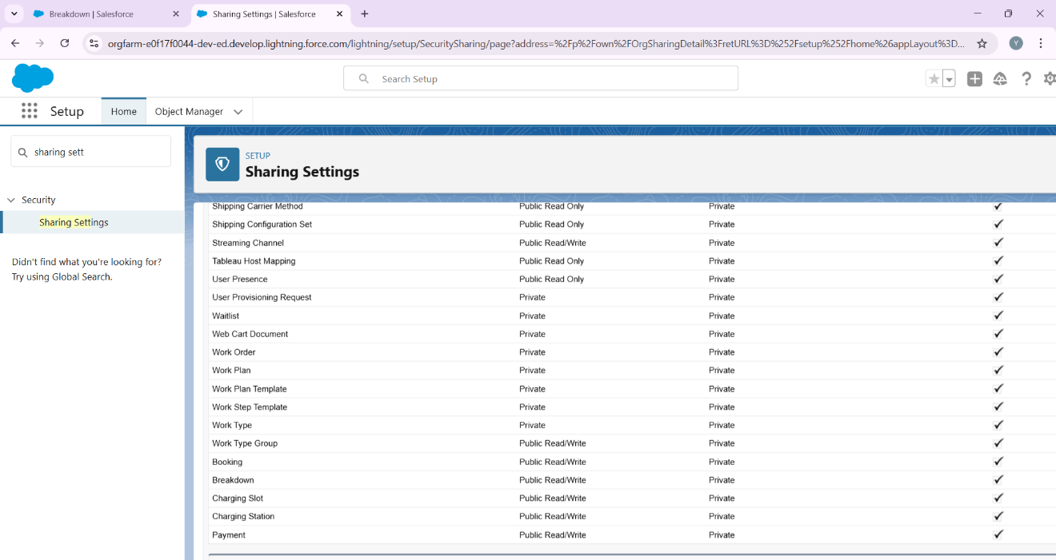

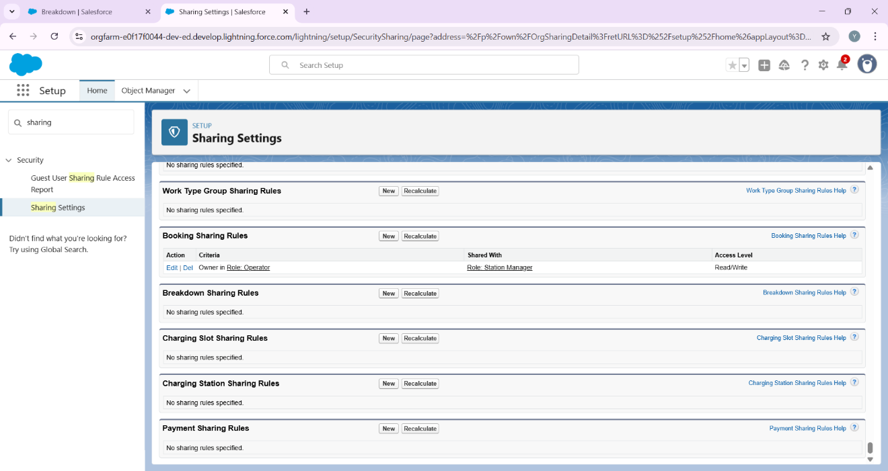

## **11. Login Access Policies**

• Restrict agent login hours (9 AM – 6 PM).  
• Restrict login IP ranges to office location (optional).

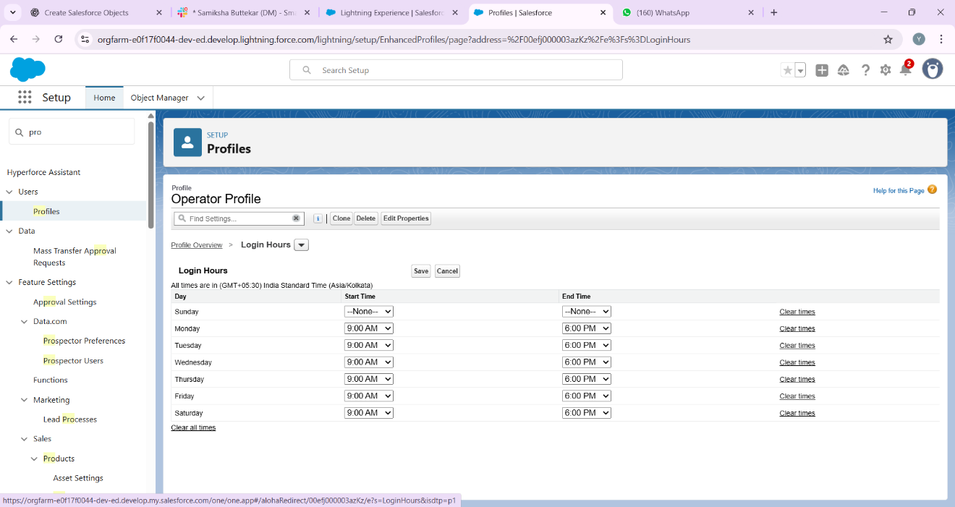

## **12. Developer Org Setup**

• Treat this org as a sandbox environment for testing.  
• Build and test features here before deploying to production (if this were a real company).



## **13. Deployment Basics**

• If working in teams or moving to production:  
 - Use Change Sets for deployment.  
 - Document all configurations.  
 - Follow best practices for backup before deployment.

# **EV Charging Station CRM – Phase 3: Data Modeling & Relationships**

Goal: Build the data structure (custom objects, fields, relationships) for the EV Charging Station CRM. Follow this step-by-step guide to create objects, fields, relationships, record types, page layouts, and validations without errors.

## Overview: Objects we will create

Standard Object:  
• Contact (use this for customers)  
  
Custom Objects (recommended):  
• Charging Station (Charging_Station__c)  
• Charging Slot (Charging_Slot__c)  
• Charging Session / Booking (Charging_Session__c)  
• Payment (Payment__c)  
• Breakdown / Service Request (Breakdown__c)  
  
Note: Names in parentheses are suggested API names.

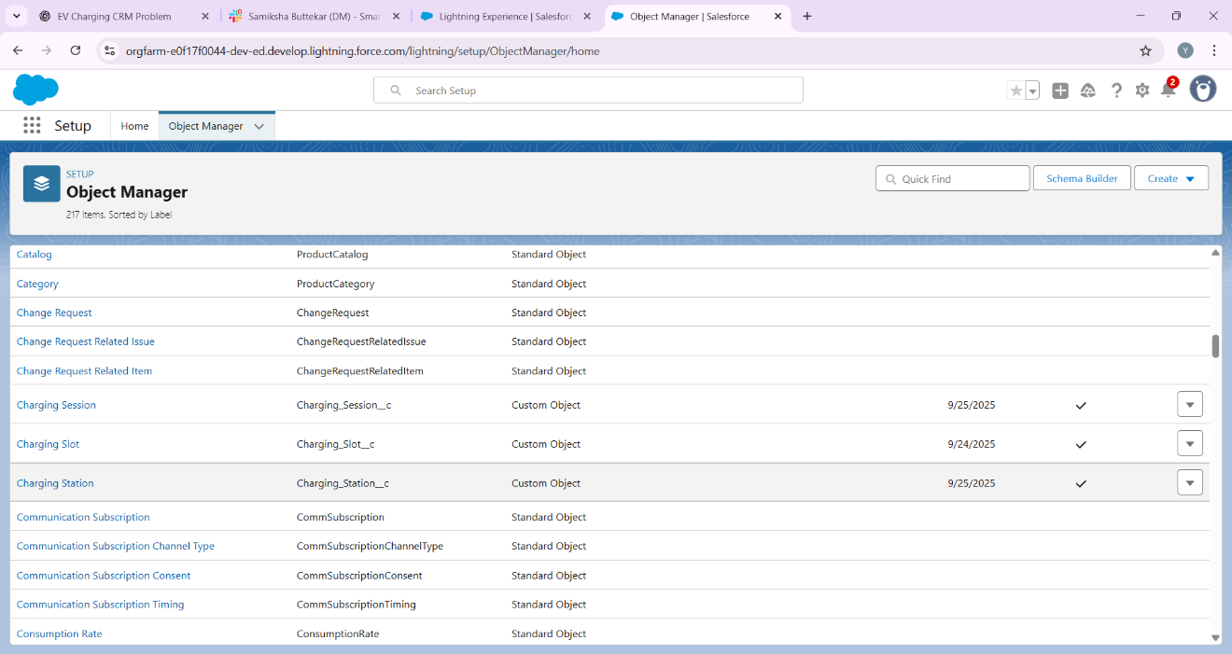

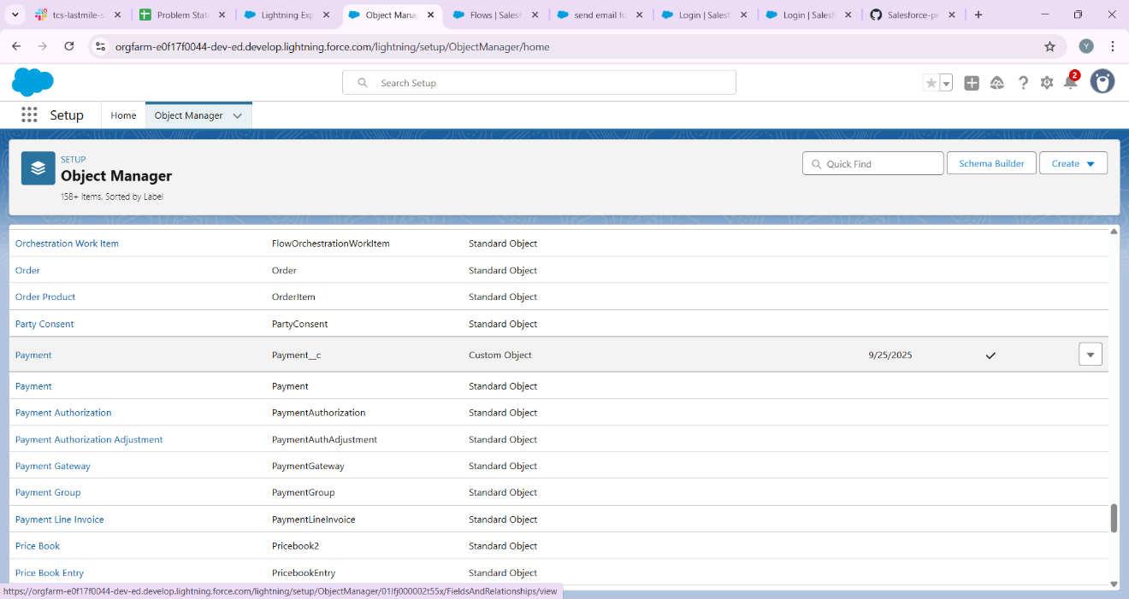

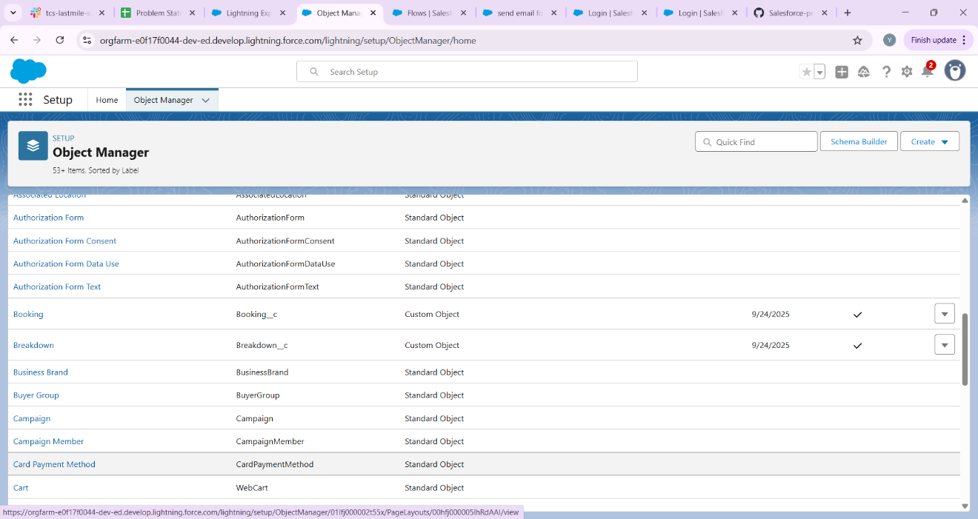

## **Step 1 — Create Custom Object: Charging Station**

Path: Setup → Object Manager → Create → Custom Object  
  
Create object with:  
• Label: Charging Station  
• Plural Label: Charging Stations  
• Object Name (API): Charging_Station  
• Record Name: Name (Text)  
• Optional: Auto-Number for Station ID if you want a unique code (e.g., STN-{0000})  
• Check: Allow Reports, Allow Activities, Track Field History (optional)  
  
Save the object. Then create fields for Charging Station:

Recommended fields (Field Label — API Name — Data Type — Notes):  
• Location — Location__c — Text (255)  
• Capacity — Capacity__c — Number (0) — number of connectors  
• Station Type — Station_Type__c — Picklist (Fast, Slow, Mixed)  
• Manager — Manager__c — Lookup(User)  
• Status — Status__c — Picklist (Active, Inactive)  
• Default Rate per kWh — Default_Rate_per_kWh__c — Currency (2)  
• Notes — Notes__c — Long Text Area



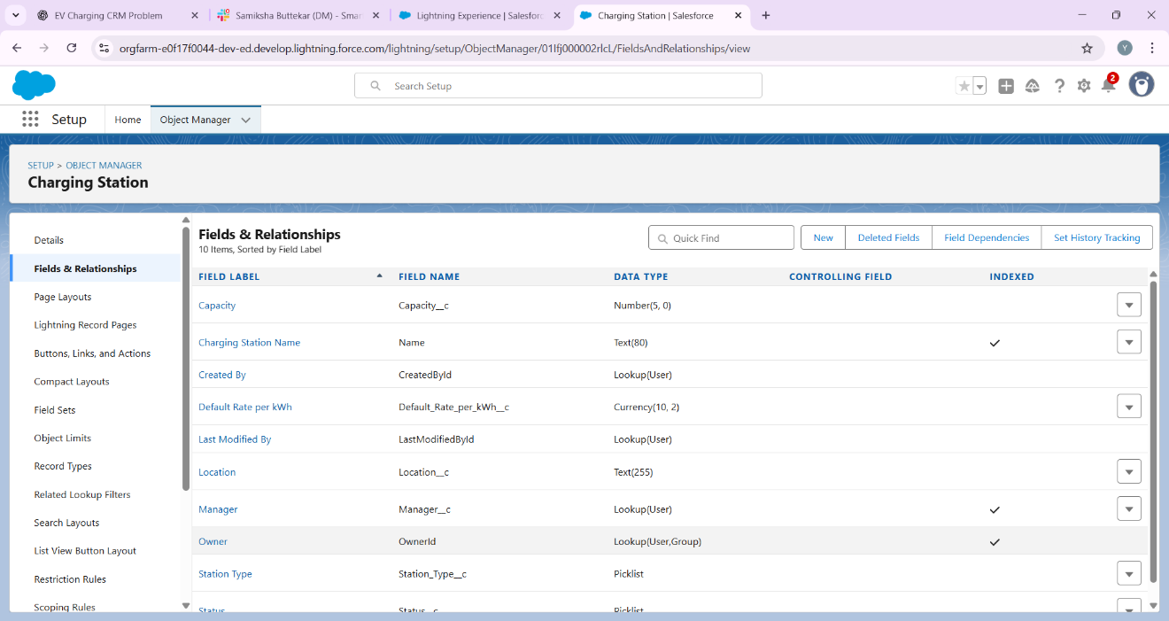

## **Step 2 — Create Custom Object: Charging Slot**

Path: Setup → Object Manager → Create → Custom Object  
  
Create object with:  
• Label: Charging Slot  
• Plural Label: Charging Slots  
• Object Name (API): Charging_Slot  
  
Recommended fields:  
• Slot Number — Slot_Number__c — Text(50)  
• Station — Station__c — Lookup(Charging_Station__c) (required)  
• Slot Status — Slot_Status__c — Picklist (Available, Booked, Occupied, Maintenance)  
• Charger Type — Charger_Type__c — Picklist (Type2, CCS, CHAdeMO, Fast)  
• Current Booking — Current_Booking__c — Lookup(Charging_Session__c) (optional)  
• Notes — Notes__c — Long Text Area  
  
Make Station lookup required if you want every slot to belong to a station.

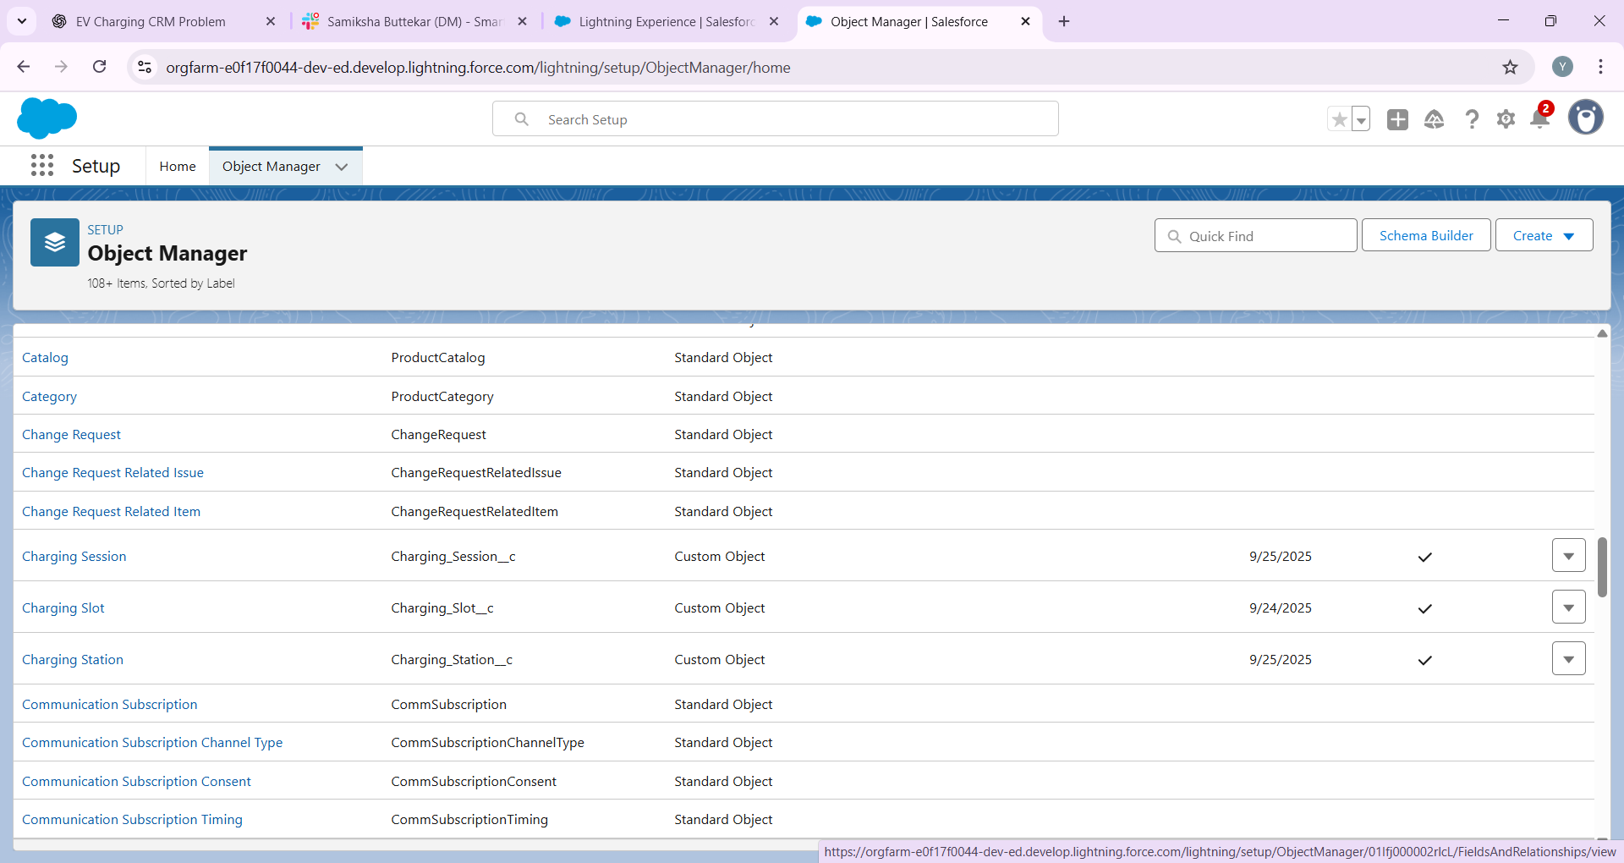

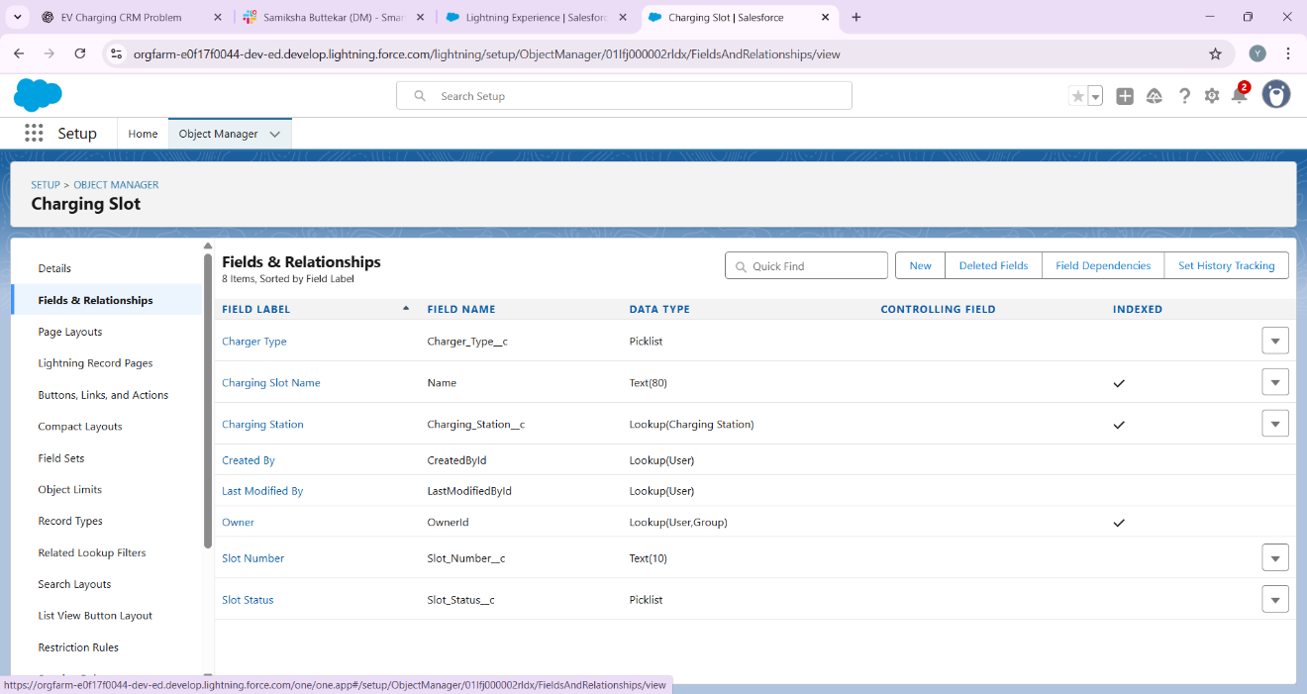

## **Step 3 — Create Custom Object: Charging Session (Booking)**

Path: Setup → Object Manager → Create → Custom Object  
  
Create object with:  
• Label: Charging Session  
• Plural Label: Charging Sessions  
• Object Name (API): Charging_Session  
• Record Name: Auto Number (recommended) — Format: CS-{0000}  
  
Recommended fields:  
• Customer — Customer__c — Lookup(Contact)  
• Slot — Slot__c — Lookup(Charging_Slot__c) (required)  
• Station — Station__c — Lookup(Charging_Station__c) (optional, can be populated by flow/formula)  
• Start DateTime — Start_Datetime__c — DateTime  
• End DateTime — End_Datetime__c — DateTime  
• Energy Consumed (kWh) — Energy_kWh__c — Number(10,2)  
• Rate Per kWh — Rate_per_kWh__c — Currency(2)  
• Total Amount — Total_Amount__c — Currency(2) — Formula (see below)  
• Booking Status — Booking_Status__c — Picklist (Requested, Confirmed, In Progress, Completed, Cancelled)  
• Payment Status — Payment_Status__c — Picklist (Pending, Paid, Failed)  
• External Transaction ID — External_Booking_Id__c — Text(100)  
  
Total Amount formula examples:  
• If charging is billed by energy: Total_Amount__c = Energy_kWh__c * Rate_per_kWh__c  
• If billed by duration: create formula DurationMinutes__c = (End_Datetime__c - Start_Datetime__c) * 24 * 60  
 then Total_Amount__c = DurationMinutes__c * Rate_per_Minute__c  
  


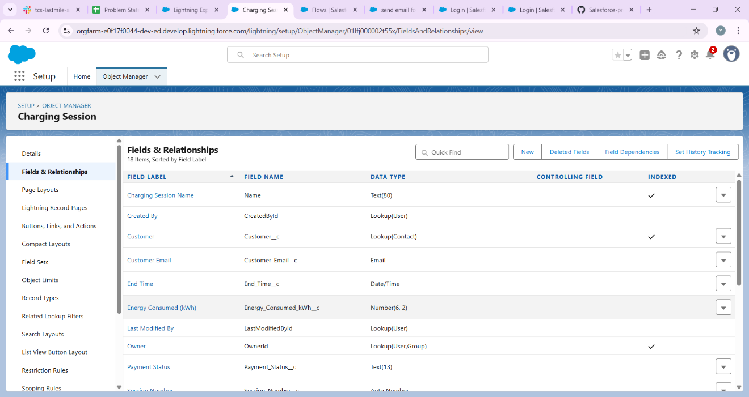

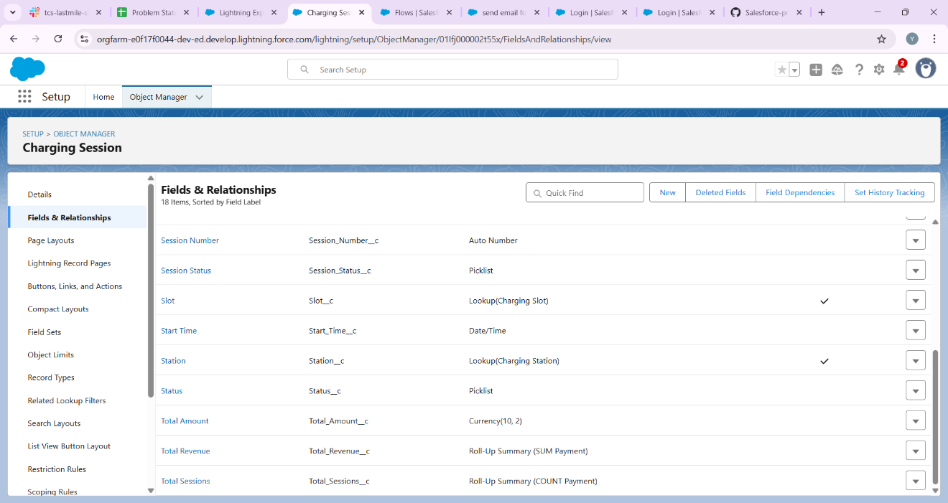

## **Step 4 — Create Custom Object: Payment**

Recommended fields:  
• Booking — Booking__c — Lookup(Charging_Session__c) (required)  
• Amount — Amount__c — Currency(2) (required)  
• Payment Date — Payment_Date__c — DateTime  
• Payment Mode — Payment_Mode__c — Picklist (Card, UPI, Wallet, Cash)  
• Transaction ID — Transaction_Id__c — Text(150)  
• Payment Status — Payment_Status__c — Picklist (Pending, Success, Failed)  
  
If you need roll-up of payments to Booking, use Master-Detail (Payment -> Booking) to enable Roll-Up Summary fields, or use Flow to sum payments.



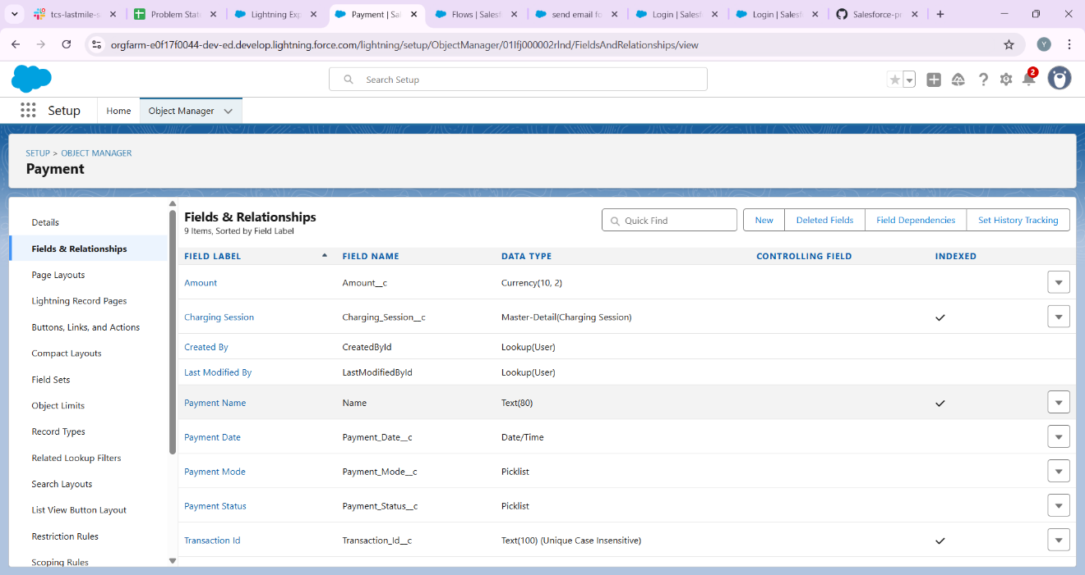

## **Step 5 — Create Custom Object: Breakdown / Service Request**

Recommended fields:  
• Station — Station__c — Lookup(Charging_Station__c)  
• Slot — Slot__c — Lookup(Charging_Slot__c)  
• Reported By — Reported_By__c — Lookup(Contact) or Lookup(User)  
• Reported Date — Reported_Date__c — DateTime  
• Severity — Severity__c — Picklist (Low, Medium, High, Critical)  
• Status — Status__c — Picklist (New, In Progress, Resolved)  
• Assigned To — Assigned_To__c — Lookup(User)  
• Description — Description__c — Long Text Area



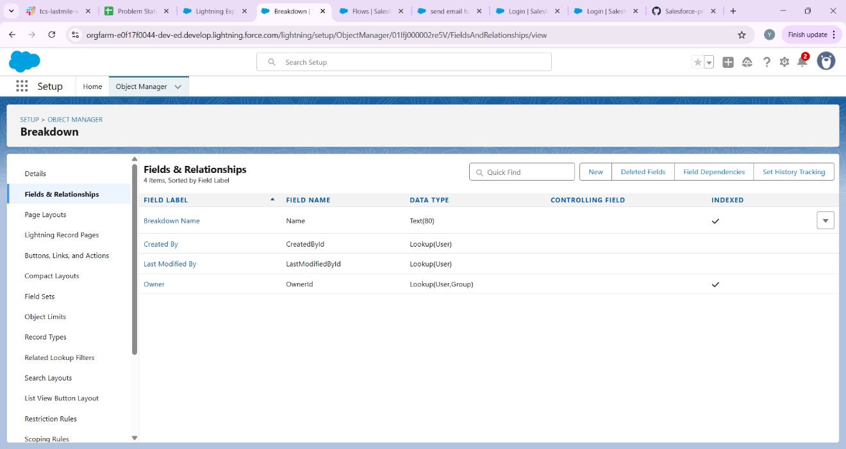

## **Step 6 — Record Types & Page Layouts**

Record Types:  
• Charging Session: create record types if you bill differently (e.g., One-Time, Subscription).  
  
Page Layouts:  
• Charging Station layout: show Station fields and related lists (Slots, Breakdowns, Sessions).  
• Charging Slot layout: include Station lookup, Slot Status, Current Booking, related Sessions.  
• Charging Session layout: include Customer, Slot, Start/End DateTime, Energy, Total Amount, Payments.  
  
Compact Layouts (for mobile) examples:  
• Charging Session compact: Name, Start_Datetime__c, Booking_Status__c  
• Charging Slot compact: Slot_Number__c, Slot_Status__c

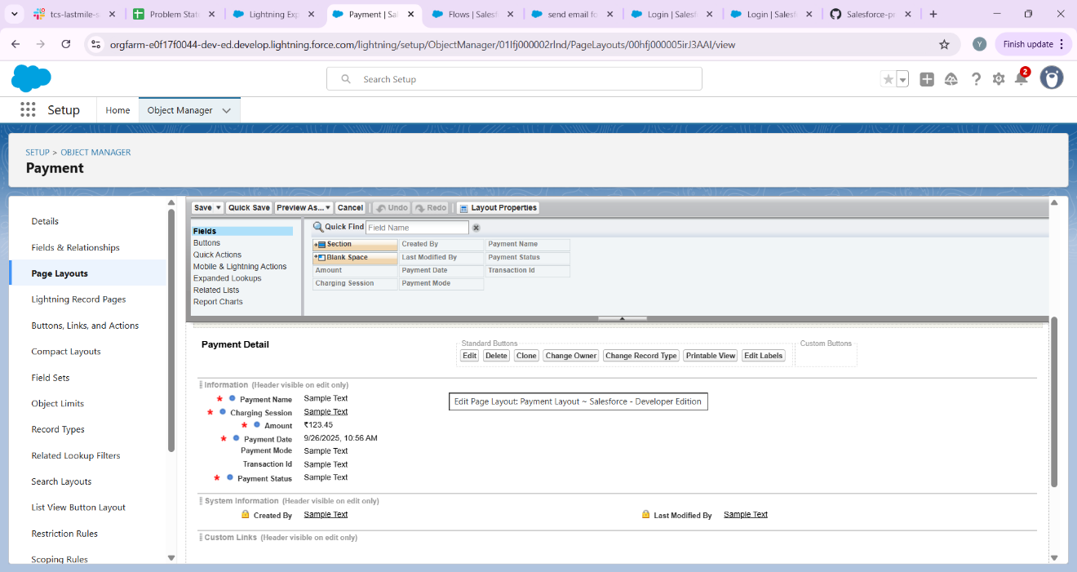

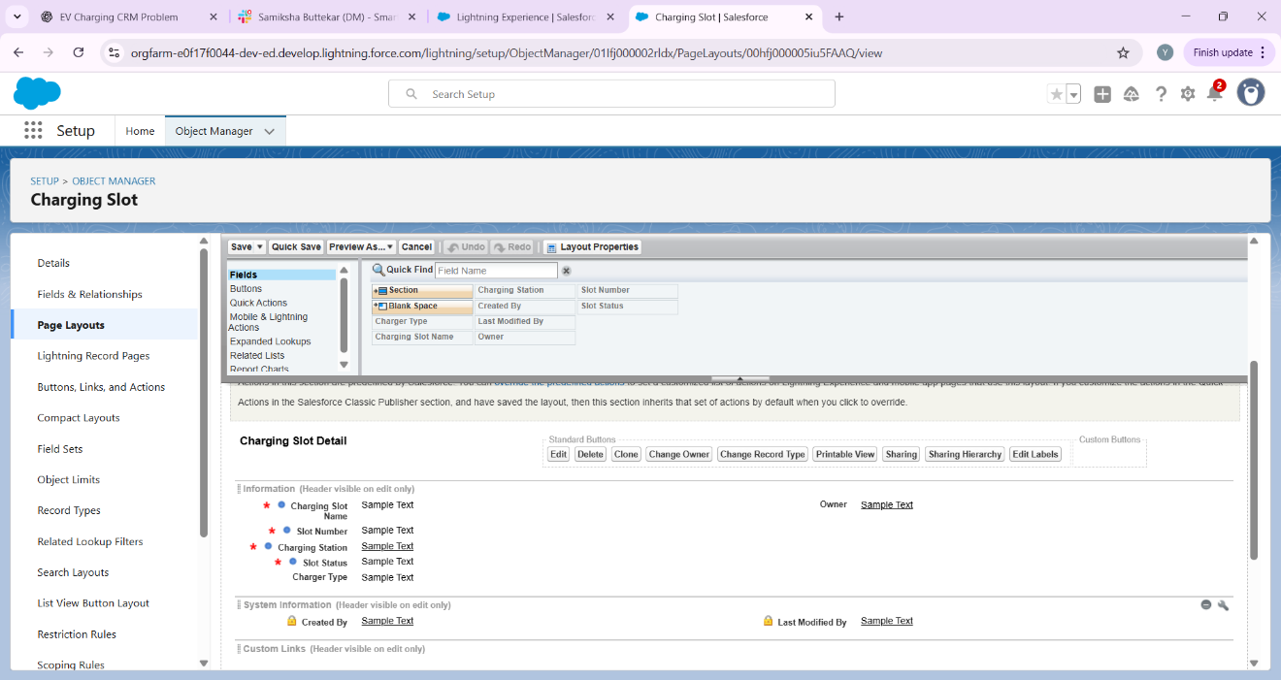

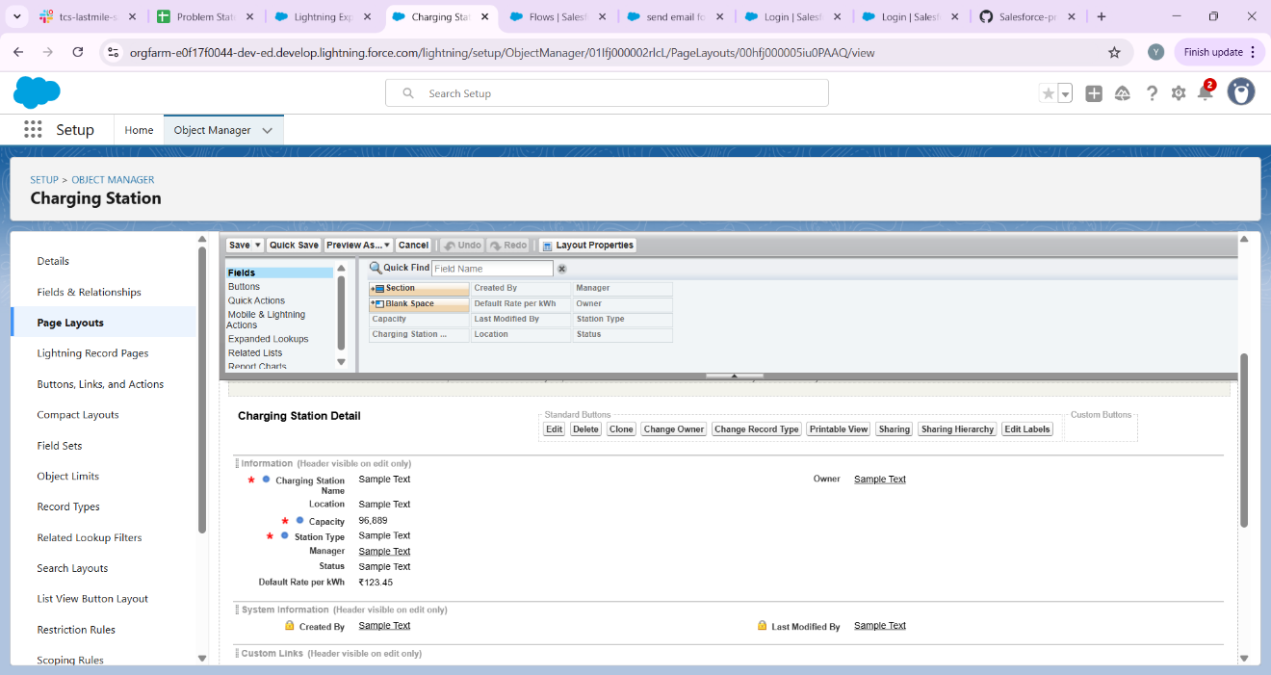

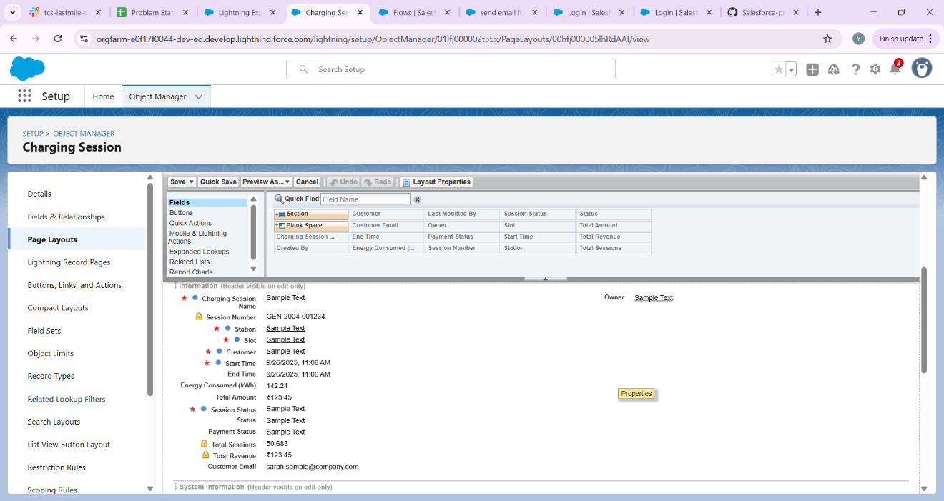

## **Step 7 — Schema Builder (visualize relationships)**

Path: Setup → Quick Find → Schema Builder  
  
Use Schema Builder to drag your custom objects onto the canvas and draw relationships. It helps to check your model visually. After creating objects and relationships in Object Manager, open Schema Builder to verify.

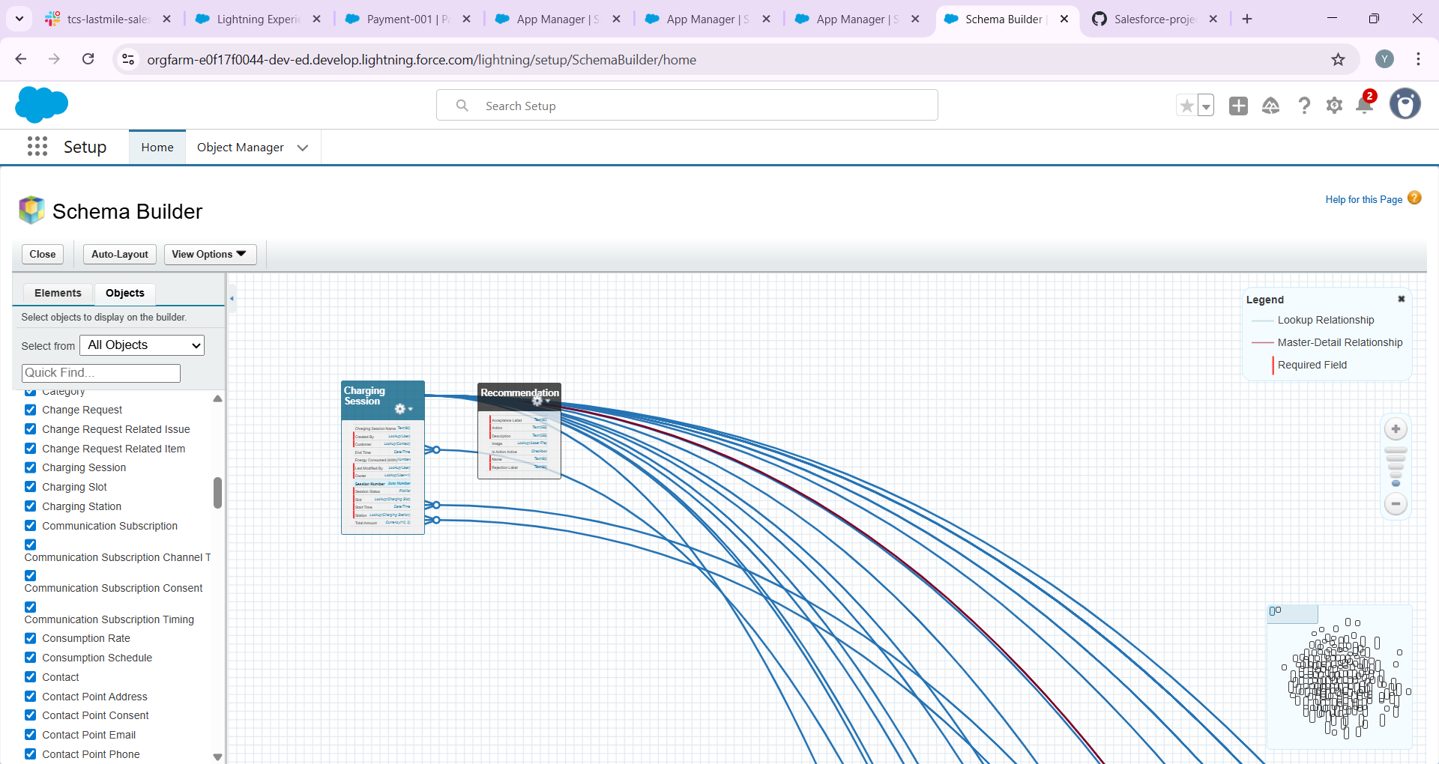

**Step 8 — Lookup vs Master-Detail (which to choose)**

General guidance for this project:  
• Charging Slot → Station: Lookup (unless you want slots deleted when Station is deleted). Lookup is safer.  
• Charging Session → Slot: Lookup (a booking references a slot).  
• Payment → Charging Session: Consider Master-Detail if you want Roll-Up Summary (Total Paid) on Session. If not, use Lookup and use Flow for aggregation.  
• Breakdown → Station/Slot: Lookup  
  
Note: Master-Detail restricts ownership & sharing (child inherits parent's owner and sharing). Use only when you want inheritance (e.g., Payment belonging tightly to a Booking).

## **Step 9 — Validation Rules & Preventing Overlapping Bookings**

Basic validation rules (formula examples):  
• Ensure End >= Start:  
 Formula (on Charging Session): End_Datetime__c >= Start_Datetime__c  
  
Prevent overlapping bookings (requires Flow or Apex):  
• Reason: Validation rules cannot query other records. Implement a Before-Save Record-Triggered Flow (recommended declarative approach) or an Apex trigger.  
• Flow logic (summary):  
 - Trigger: Charging Session (Before Save, on Create or Update)  
 - Get Records: Query Charging Sessions where Slot__c = {!$Record.Slot__c} AND Booking_Status__c != 'Cancelled' AND (Start_Datetime__c < {!$Record.End_Datetime__c})

AND (End_Datetime__c > {!$Record.Start_Datetime__c})  
 - If Get Records found any rows → Use a 'Assignment' to set an error on the record (use the 'Add Error' action) or update a field to indicate conflict and let user correct.  
  
SOQL overlap condition pseudo:  
SELECT Id FROM Charging_Session__c WHERE Slot__c = :slotId AND Start_Datetime__c < :newEnd AND End_Datetime__c > :newStart AND Booking_Status__c != 'Cancelled'

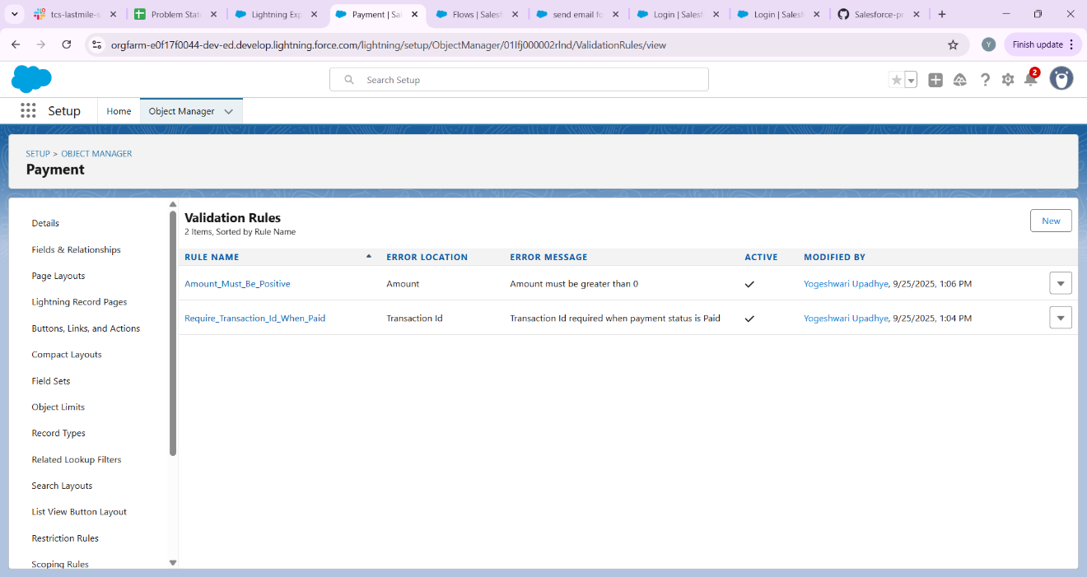

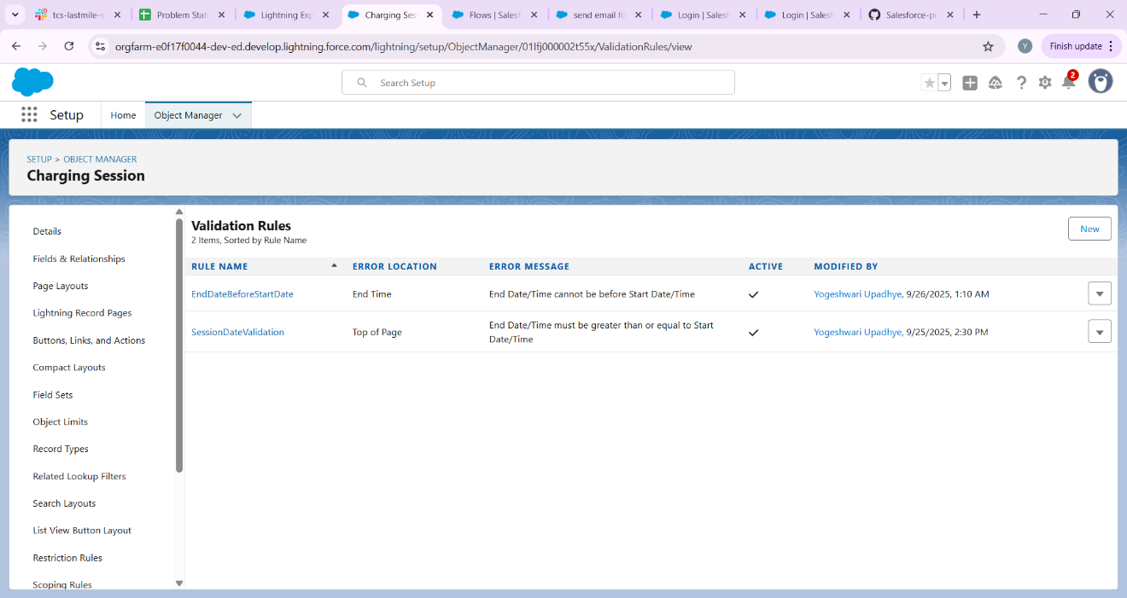

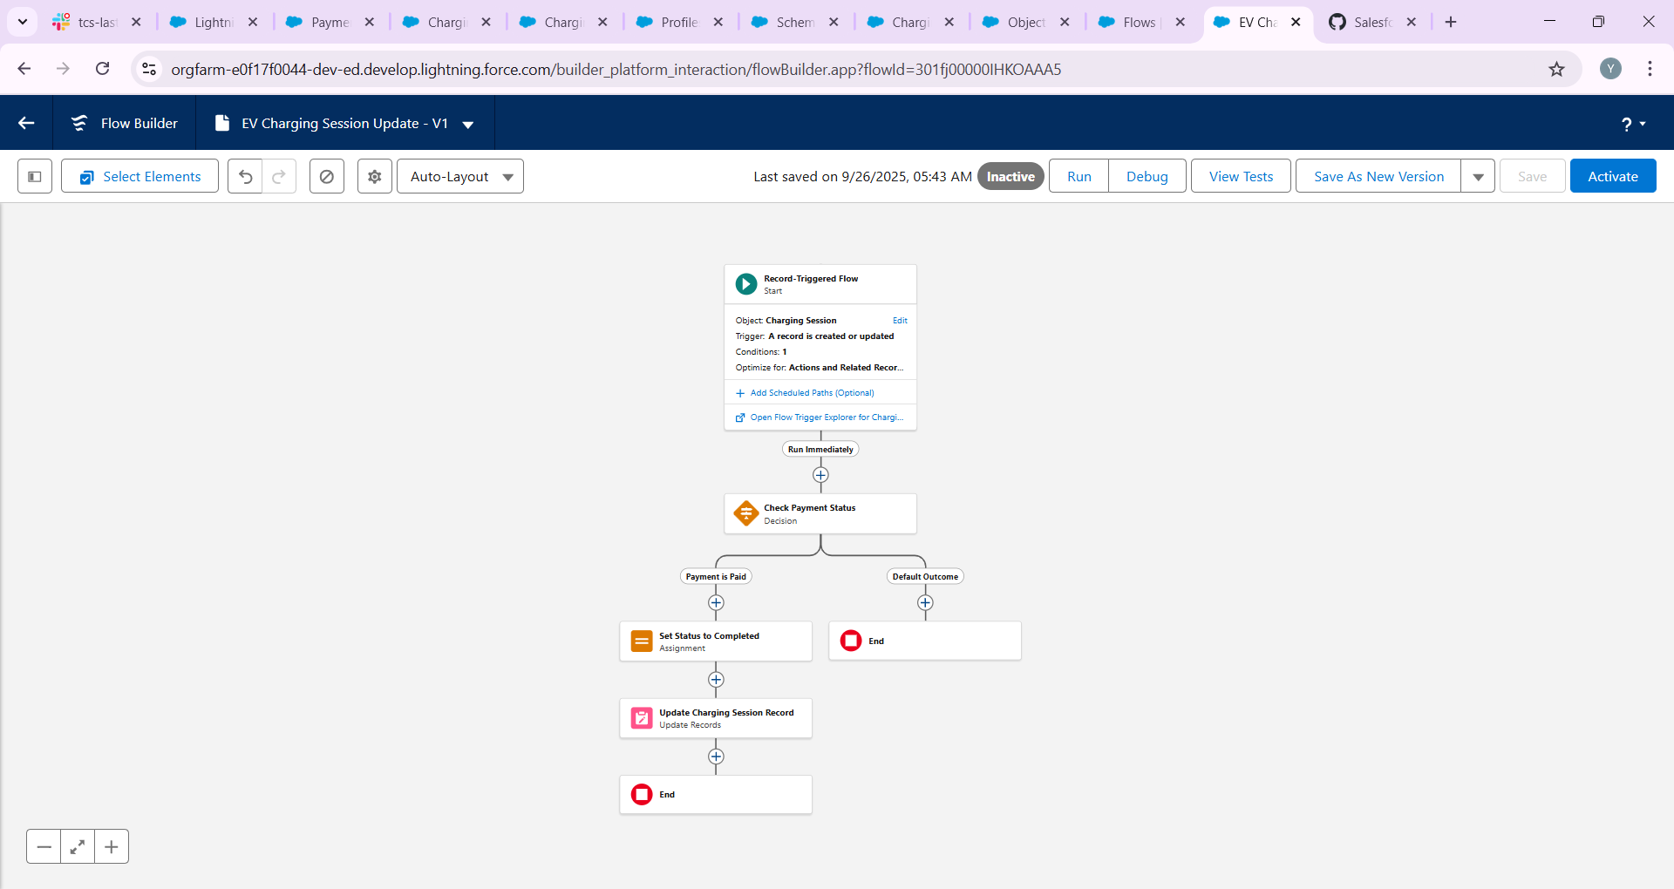

## **Step 10 — Formula Fields & Roll-up Summaries**

Useful formula fields:  
• Duration (Minutes) — Number formula on Charging Session:  
 (End_Datetime__c - Start_Datetime__c) * 24 * 60  
  
• Total Amount (energy-based):  
 Total_Amount__c = Energy_kWh__c * Rate_per_kWh__c  
  
• Or duration-based: Total_Amount__c = DurationMinutes__c * Rate_per_Minute__c  
  
Roll-up summaries:  
• If Payment is Master-Detail to Charging Session, you can create Roll-Up Summary fields on Charging Session: Total_Amount_Paid__c (SUM Payment.Amount__c)  
• Alternatively, use Flow to aggregate payments and update booking's Total_Paid__c.

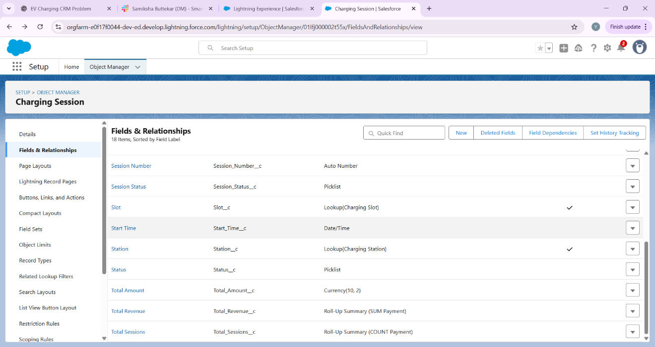

## **Step 11 — Useful List Views and Reports**

Create List Views:  
• Charging Slots: 'Available Slots' (Slot_Status__c = Available)  
• Charging Sessions: 'Today’s Sessions' (Start_Date = TODAY)  
• Payments: 'Pending Payments' (Payment_Status__c = Pending)  
  
Create Reports:  
• Revenue by Station (custom report type: Station + Session + Payment)  
• Slot Utilization (sessions per slot)  
• Breakdown Frequency (by station and severity)

## **Step 12 — Data Import & Sample Data**

• Use Data Import Wizard (Setup → Data → Import) for Contacts and up to 50,000 records.  
• Map fields carefully (e.g., Station Name → Name, Slot Station lookup requires Station record IDs or External IDs).  
• For lookups, consider creating an External ID on Stations and use it during import for easy matching.  
  
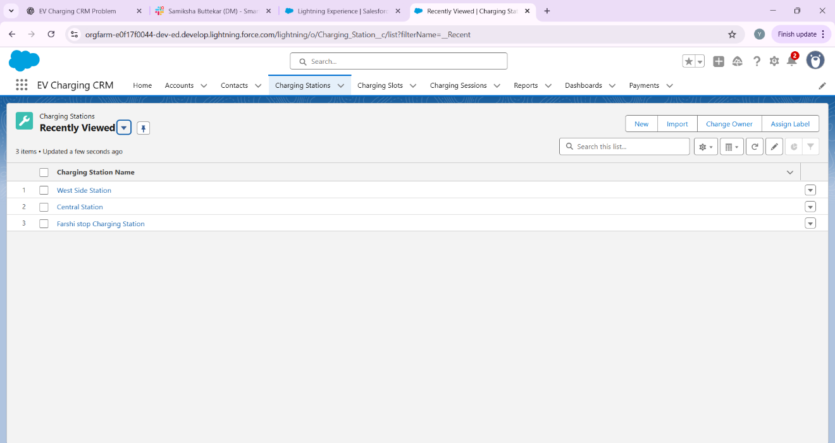

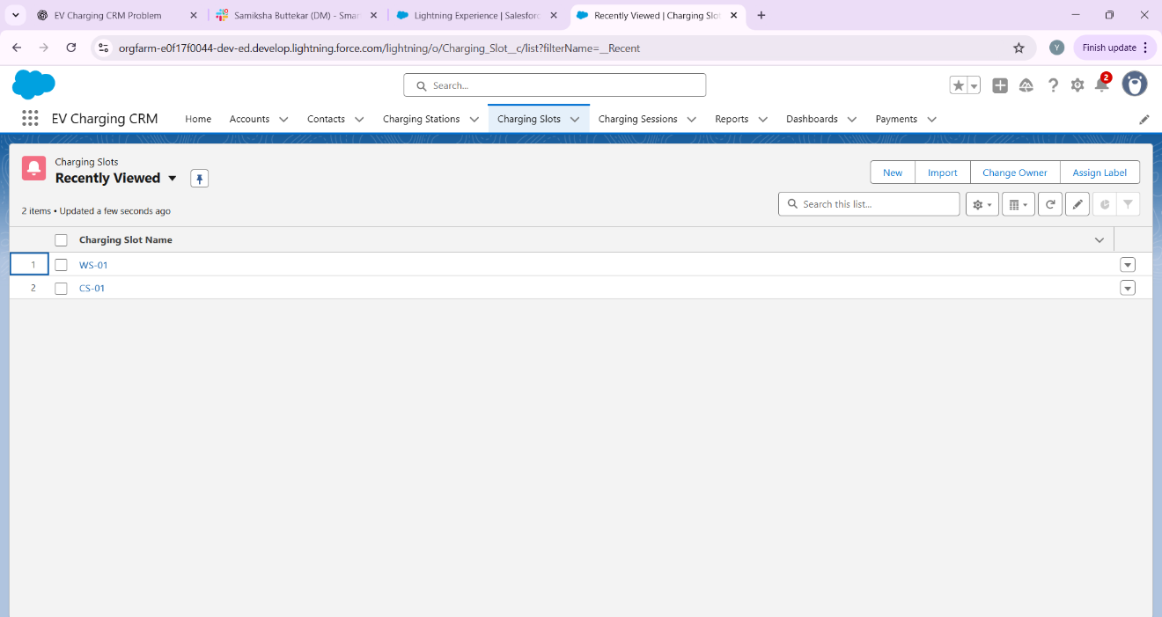

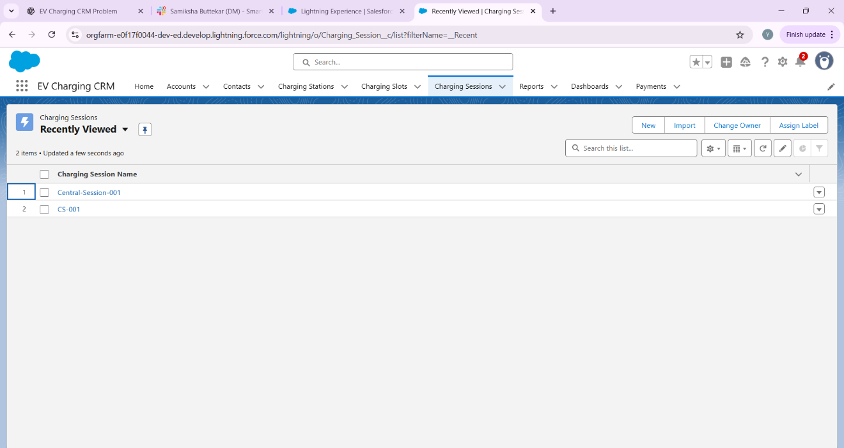

**Phase 4: Process Automation (Admin) - EV Charging CR**

Goal: Automate tasks in EV Charging CRM for efficiency and reduce manual work.

# **1.Validation Rules**

Objective: Ensure data integrity example: Charging End Time must be after Start Time.

* Setup → Object Manager → Charging Session → Validation Rules → New.
* Formula: End_Time__c < Start_Time__c
* Error Message: “End Time must be after Start Time.”
* Error Location: End Time field.



# **2.Workflow Rules (Legacy)**

Objective: Auto-send email when a Charging Session is created (for reference).

* Setup → Workflow Rules → New Rule → Object: Charging Session.
* Rule Criteria: Created.
* Action: Send Email Alert to Customer.

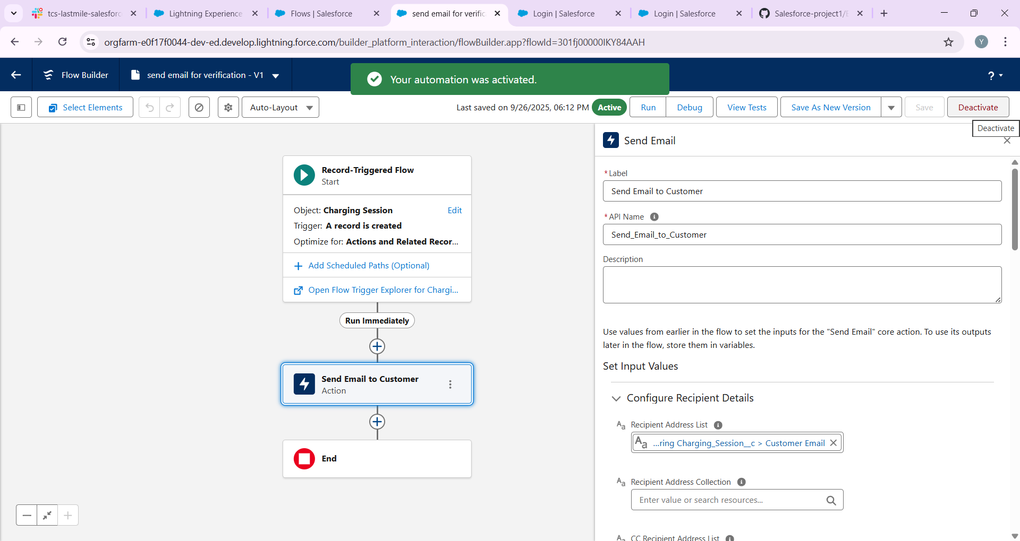

# **3.Process Builder (Legacy)**

Objective: Auto-update Charging Session Status from 'Pending' → 'Completed'.

Screenshot: [Attach Process Builder canvas screenshot here]

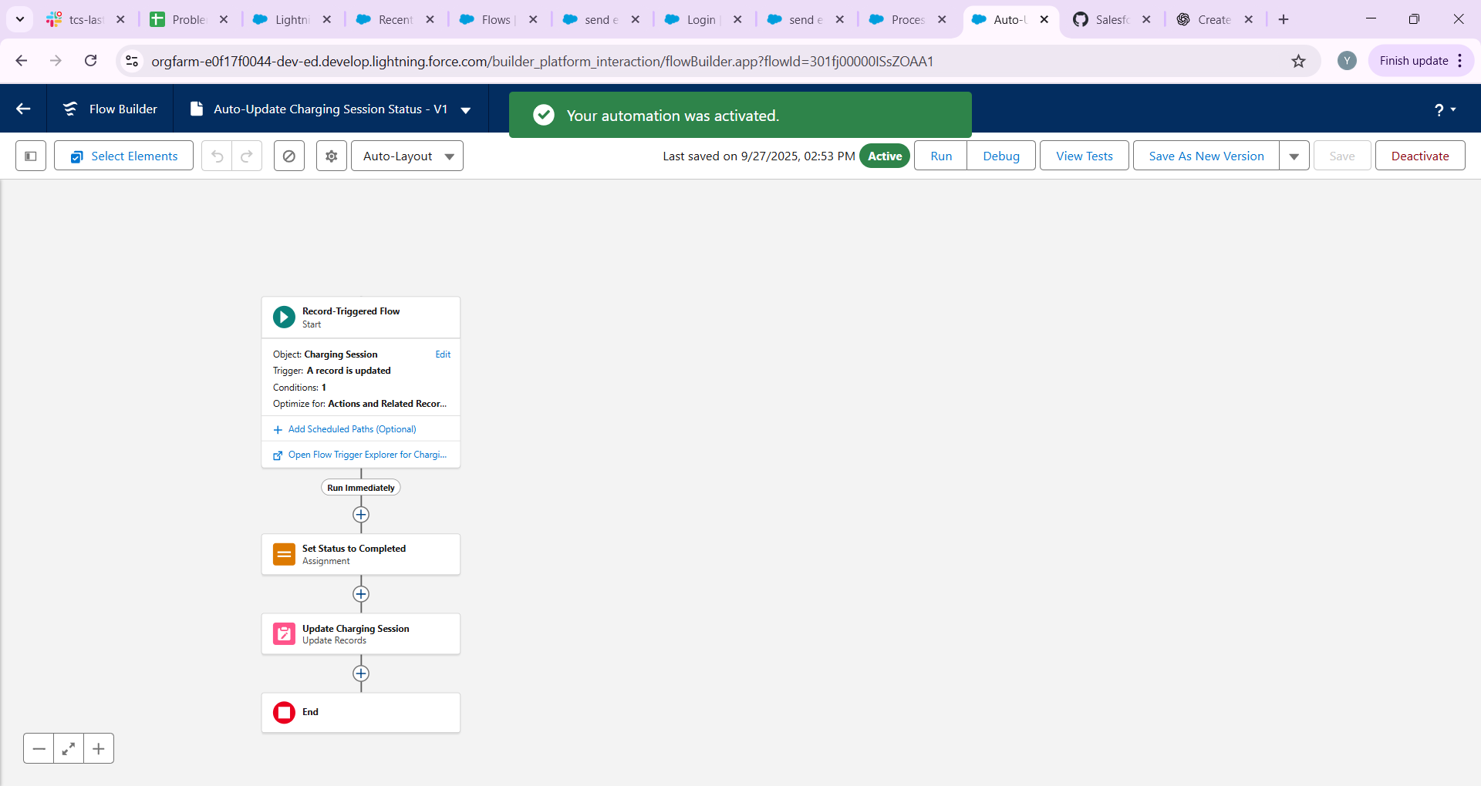

# **4.Approval Process**

Objective: High-value sessions require Manager approval.

* Setup → Approval Processes → Create New Approval Process → Use Wizard.
* Entry Criteria: Total Amount > 5000.
* Approver: Manager.
* Actions: Initial Submission → Send Email to Manager.
* Final Approval → Update Status = 'Approved'.

When a **Charging Session** is created/updated with **Total Amount > ₹50,000**:

* User clicks **Submit for Approval** on the record.
* Request goes to **Manager**.
* Manager gets an **email notification** + can **Approve/Reject**.
* Once approved → you can add an **action** (like update Booking Status to Confirmed).

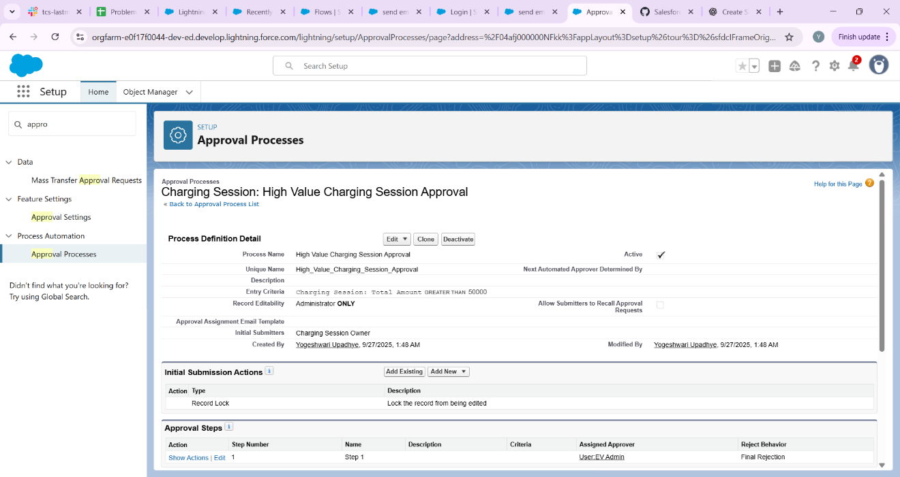

# **6.Flow Builder**

Objective: A. Record-Triggered Flow – Auto-calculate Total Amount  
B. Screen Flow – Booking Form

* Record-Triggered Flow Steps:
* 1. Setup → Flow → New → Record-Triggered Flow.
* 2. Object: Charging Session → Trigger: Created or Updated.
* 3. Add Assignment → Set $Record.Total_Amount__c = $Record.Charging_Units__c * $Record.Rate_per_kWh__c
* 4. Update Record → $Record.
* Screen Flow Steps:
* 1. Setup → Flow → New → Screen Flow.
* 2. Add Screen → Fields: Customer Name, Vehicle, Start/End Time, Charging Units.
* 3. Submit Button → Create Charging Session Record.

# **8.Email Alerts**

Objective: Notify customers after approval.

* Setup → Email Alerts → New → Object: Charging Session.
* Recipients → Customer Email.
* Template → 'Your EV charging session is confirmed.'

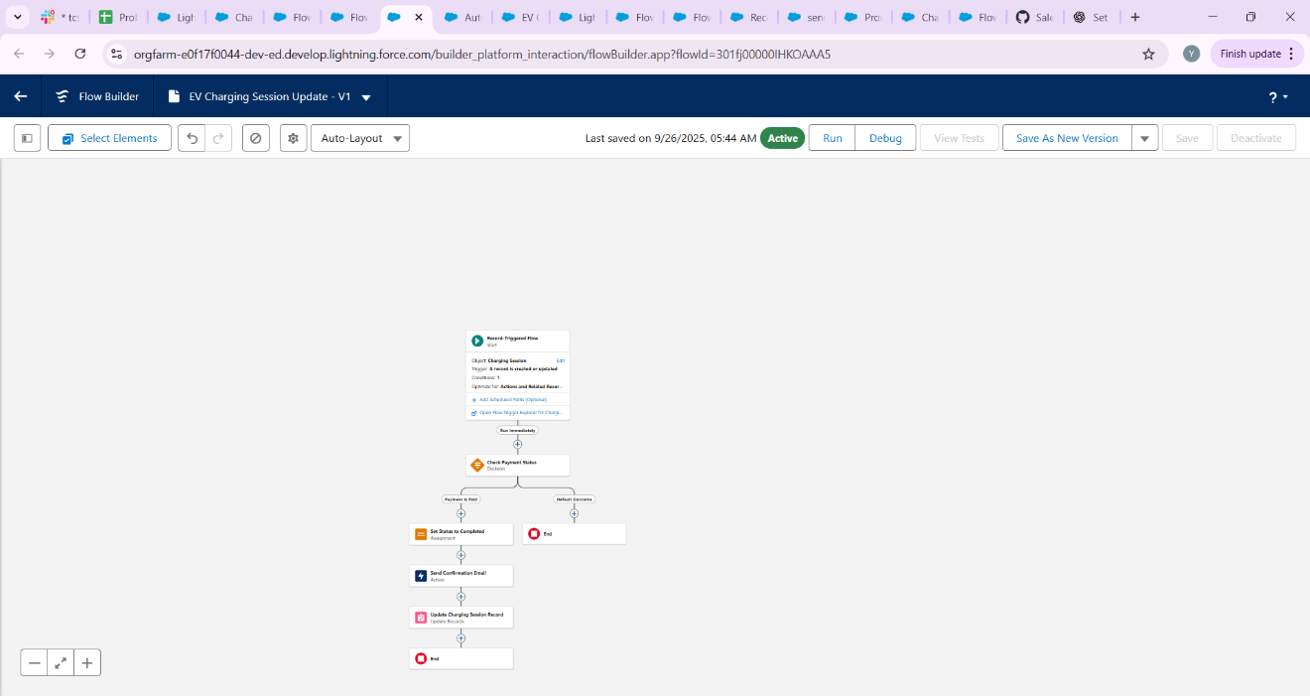

# **9.Field Updates**

Objective: Update Booking Status automatically.

* After Approval → Status = 'Confirmed'.

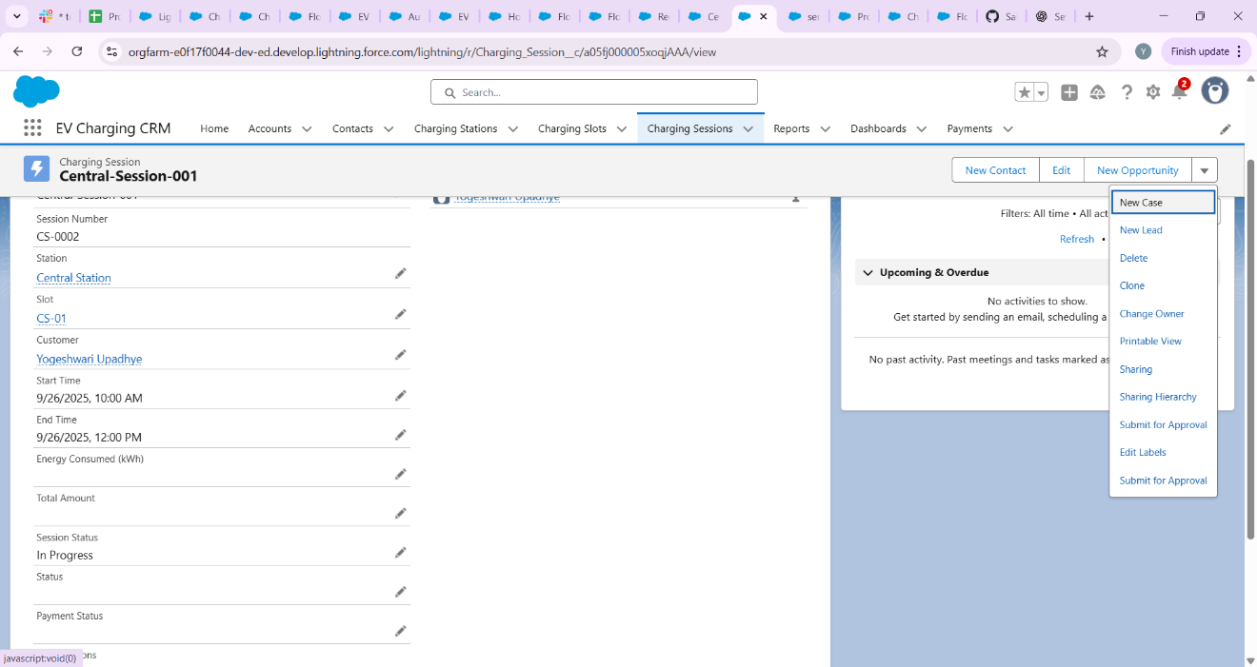

**Phase 5: Apex Programming (Developer)**

**Goal:** Add advanced logic to the EV Charging CRM.

**1. Classes & Objects**

* **Create a Booking Service class** to handle reusable logic related to charging session bookings. This class can include methods for:
  + Creating a new booking.
  + Validating booking times.
  + Calculating total charges based on duration and energy consumed.

**2. Apex Triggers**

* **On Charging Session Insert:**

Prevent overlapping charging sessions for the same vehicle.

Ensure that a vehicle isn't booked for multiple sessions at the same time.

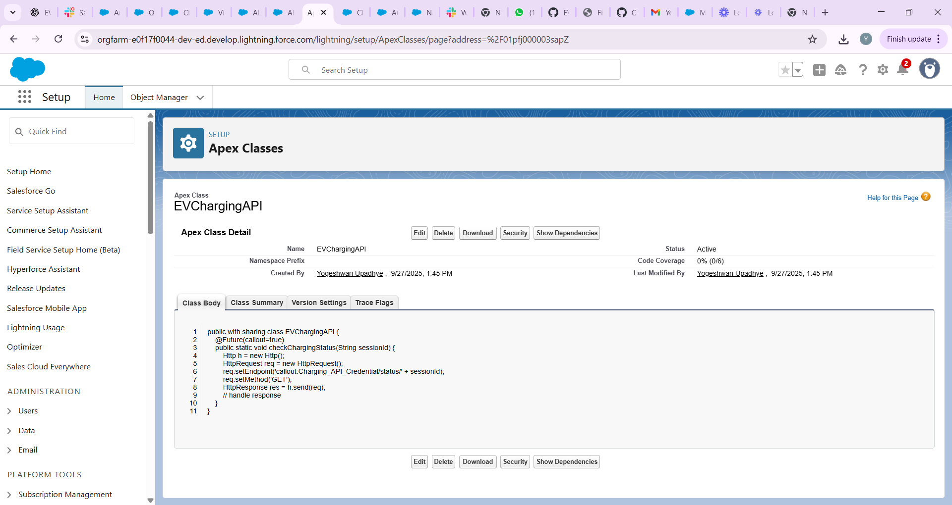

Go to **Setup → Apex Classes → New**.

|  |
| --- |
| trigger BookingTrigger on Booking__c (before insert, before update) {  for (Booking__c b : Trigger.new) {  if (BookingService.isBookingOverlap(b.Start_Time__c, b.End_Time__c, b.Charger__c)) {  b.addError('This charging station is already booked for the selected time.');  }  }  } |

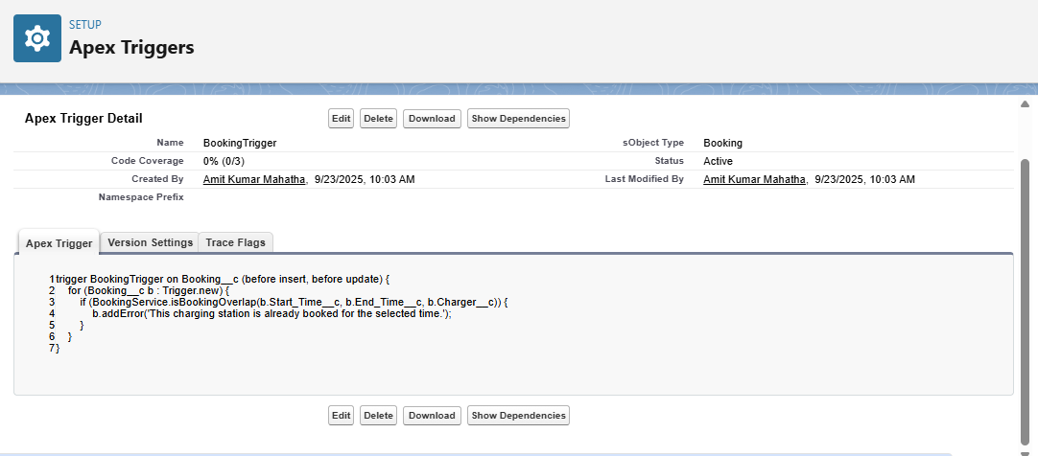

**3. Trigger Design Pattern**

* **Use a Handler Class:**
  + Implement a handler class to separate logic from the trigger.
  + This approach enhances code modularity and maintainability.
  + For more information on the trigger handler pattern, refer to this article: Trigger Handler Pattern in Salesforce.

**4. SOQL & SOSL**

* **Query Available Charging Stations:**
  + Use SOQL to retrieve charging stations with available slots.
  + Example query:
  + SELECT Id, Name FROM Charging_Station__c WHERE Status__c = 'Available'
  + This ensures that users can only book available stations.

**5. Collections: List, Set, Map**

* **Store Vehicle IDs in a Set:**
  + Utilize a Set to store vehicle IDs to avoid duplicates.
  + Example:
  + Set<Id> vehicleIds = new Set<Id>();
  + This ensures that each vehicle is processed only once.

**6. Control Statements**

* **Check for Overlapping Sessions:**
  + Use if statements to check if the requested booking time overlaps with existing sessions.
  + If overlap is detected, throw a custom exception:
  + if (overlapExists) {
  + throw new BookingOverlapException('The vehicle is already booked during this time.');
  + }

**7. Batch Apex**

* **Night Job to Mark Overdue Rentals:**
  + Implement a batch job to identify and mark overdue rentals.
  + This can be scheduled to run during off-peak hours to update records efficiently.

**8. Queueable Apex**

* **Asynchronous Calculation of Discounts:**
  + Use Queueable Apex to calculate discounts for bulk rentals asynchronously.
  + This allows for complex calculations without impacting user experience.

**9. Scheduled Apex**

* **Daily Email to Manager:**
  + Schedule an Apex job to send a daily email to the manager with a list of today's rentals.
  + This can be achieved using the Schedulable interface.

**10. Future Methods**

* **Call External Insurance API:**
  + Implement a future method to call an external insurance API asynchronously.
  + This ensures that the main transaction isn't delayed by external calls.

**11. Exception Handling**

* **Catch Errors for Overlapping Bookings:**
  + Implement custom exception handling to catch errors related to overlapping bookings.
  + Provide meaningful error messages to users.

# **Phase 6: User Interface Development – EV Charging CRM**

Goal: Make the CRM interface user-friendly and tailored to EV Charging operations.

## **1. Lightning App Builder**

• Create an app named “EV Charging CRM”.  
• This app will group all related objects (Charging Sessions, Stations, Bookings, Payments, etc.) in one workspace.  
  
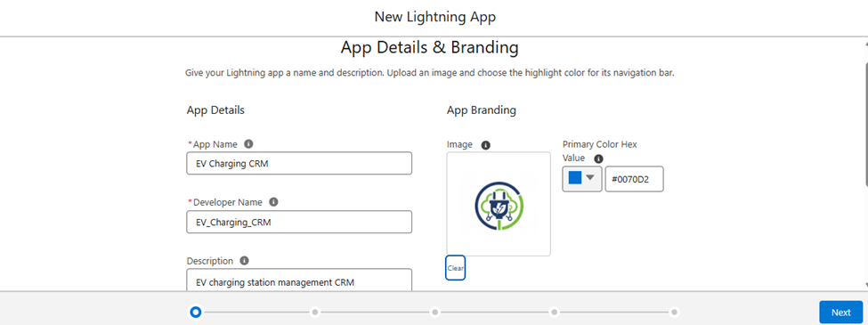

## **2. Record Pages**

• Charging Station page → Should display a related list of Charging Slots and Charging Sessions.  
• Charging Session page → Should show Payment Details and Customer Information.  
  
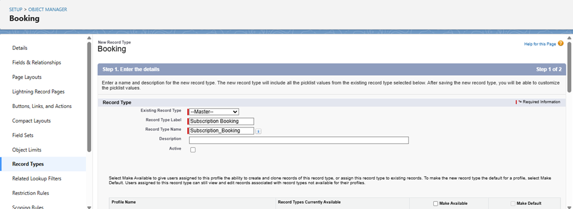

## **3. Tabs**

• Add Charging Stations, Charging Sessions, Bookings, Payments as navigation tabs.  
• This helps operators/managers quickly switch between key records.

## **4. Home Page Layouts**

• Add a Dashboard component that shows:  
 - Total Active Charging Sessions  
 - Station Utilization (per station)  
 - Revenue Trend  
  
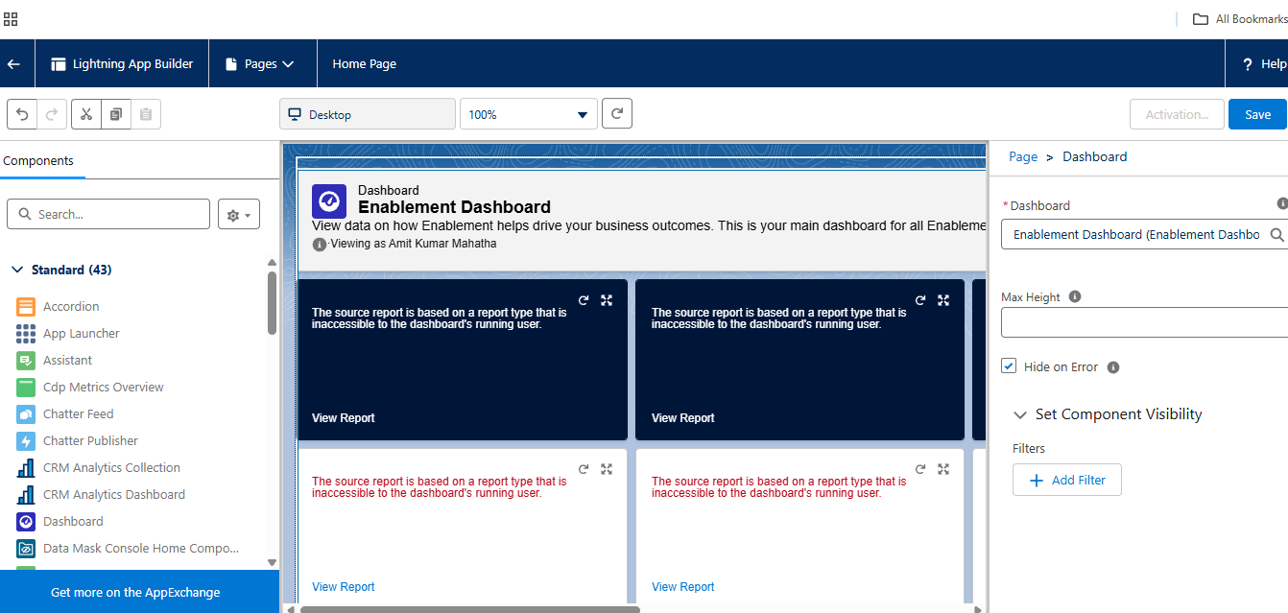

## **5. Utility Bar**

• Add a quick action: “New Charging Session”.  
• Allows operators to start a session directly from anywhere in the app.

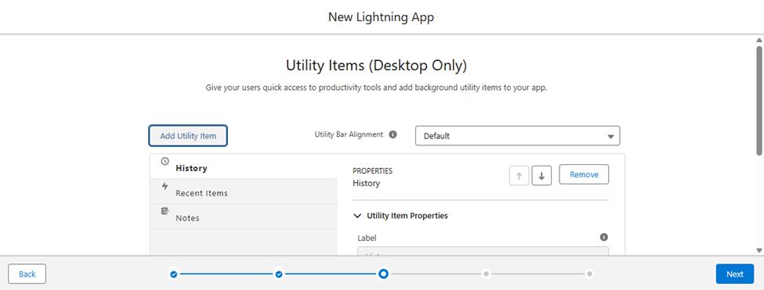

## **6. Lightning Web Components (LWC)**

• Component: Search Available Stations by Date/Time  
 - Input: Date, Time, Region.  
 - Output: Available charging stations in a datatable format.

## **7. Apex with LWC**

• Use Imperative Apex call to create a new booking.  
• Example:  
 - User selects a slot → Click “Book Now” → Apex method inserts booking.

## **8. Events in LWC**

• Child component (Search Form) sends selected date/time to Parent component (Results Table).  
• Parent updates results dynamically.

## **9. Wire Adapters**

• Use @wire to fetch list of available stations from Salesforce database.  
• Automatically refreshes when filters are changed.

## **10. Imperative Apex Calls**

• When “Book Now” is clicked → Apex call inserts a new Booking record.  
• Confirmation message is shown on screen.

## **11. Navigation Service**

• After a booking is created → use NavigationMixin to redirect user to the newly created Booking record page.

**EV Charging CRM Project – Phase 7: Integration & External Access**  
  
  
 Objective  
Implement external system integration for EV Charging CRM to connect with APIs, publish events, and track changes without relying on UI or Apex triggers (can be added in later phases).  
  
  
  
**Step 1: Named Credentials**1. Go to Setup → Security → Named Credentials.  
2. Click New Named Credential.  
3. Fill in details:  
 - Label: `Charging_API_Credential`  
 - Name: `Charging_API_Credential`  
 - URL: `https://api.evcharging.com`  
 - Identity Type: Named Principal  
 - Authentication: Password or OAuth (based on API)  
4. Click Save.  
  
  
  
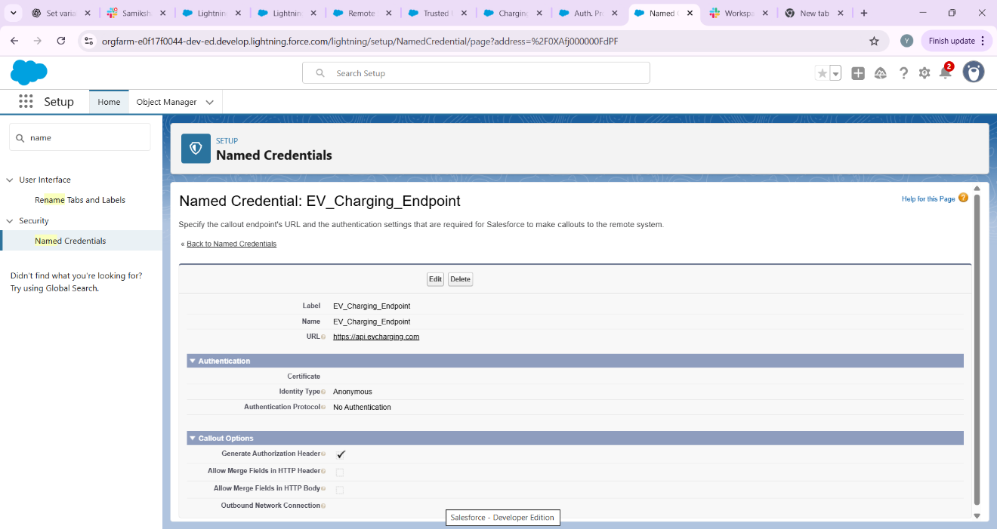

**2. External Services in Salesforce**

**External Services** is a declarative tool in Salesforce that allows you to connect to external APIs without writing custom Apex code.

**Key components:**

1. **Named Credential / External Credential**
   * Stores authentication details (OAuth 2.0, API key) securely.
   * Ensures that Salesforce can call the external API safely.
2. **Open API / Swagger specification**
   * Defines the structure of the API: endpoints, methods (GET, POST), parameters, and responses.
   * Salesforce reads this schema to generate actions that can be used in Flows or Apex.
3. **Flow / Apex Integration**
   * Once registered, the API operations appear as **invocable actions** in Flow Builder or as generated Apex classes.
   * Allows users to trigger external API calls directly from Salesforce processes.

**3. Implementation Steps (Conceptual)**

**1.Create Named Credential / External Credential**

* Normally, this stores authentication
* information (OAuth client ID/secret or API key).

**2.Register External Service**

* Upload a sample OpenAPI schema that represents the external API endpoints.
* Link it to the Named Credential for authentication.

**3.Use in Flow / Apex**

* Drag and drop generated actions into Flows.
* Map input/output variables to Salesforce records for automation.

*Note:* In this project, we do not have a real EV Charging API. Therefore, a **sample OpenAPI schema** is used to demonstrate the process conceptually. In a real-world scenario, the API provider would supply the actual OpenAPI specification and credentials.

**4. Sample Use Case**

**Use Case:** Automatically calculate the total amount for a charging session using an external EV Charging API.

1. **Scenario:** A customer starts a charging session.
2. **Flow:** Salesforce Flow triggers an API call (via External Service) to fetch session status and calculate total energy consumed.
3. **Result:** The total amount is automatically updated in the Charging_Session__c record without manual input.

**Note:** In this demo project, the API call is simulated using a sample OpenAPI schema. The Flow is configured to show how the integration would work in a real environment.

Top of Form

Bottom of Form

**Step 3: REST Callouts**  
1. Create Apex class for callout:  
  
```apex  
public with sharing class EVChargingAPI {  
 @Future(callout=true)  
 public static void checkChargingStatus(String sessionId) {  
 Http h = new Http();  
 HttpRequest req = new HttpRequest();  
 req.setEndpoint('callout:Charging_API_Credential/status/' + sessionId);  
 req.setMethod('GET');  
 HttpResponse res = h.send(req);  
 // handle response  
 }  
}  
```  
  
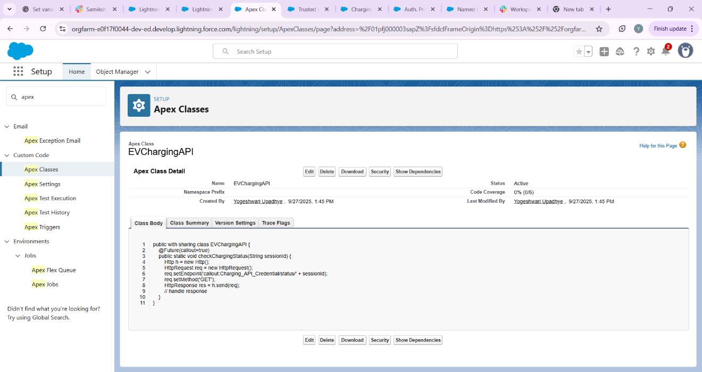

**Step 4: Platform Events**1. Setup → Platform Events → New Platform Event  
 - Name: `Charging_Slot_Updated__e`  
 - Fields: `Slot_ID__c`, `Status__c`  
2. Publish event in Flow whenever slot status changes.  
  
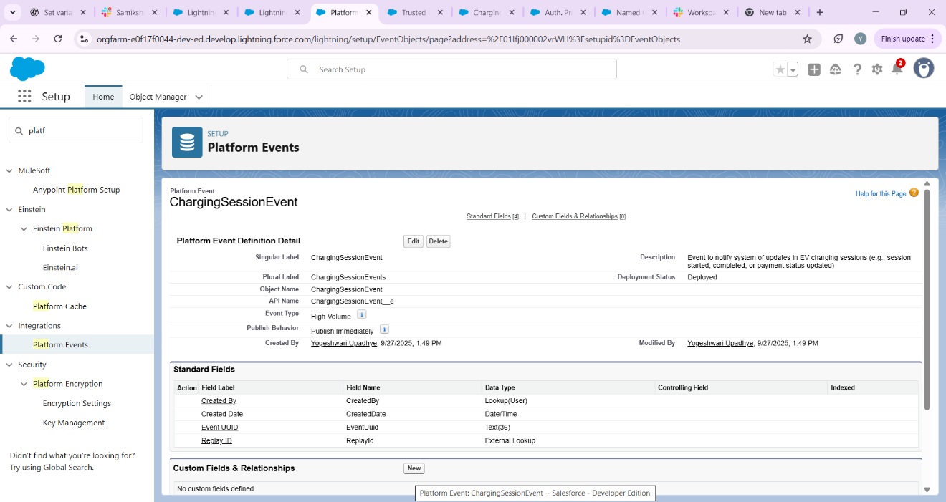  
  
  
  
 **Step 5: Change Data Capture**  
1. Setup → Change Data Capture → Select Object: `Charging_Session__c`  
2. Subscribe to updates → notify external system via Flow or Apex.  
  
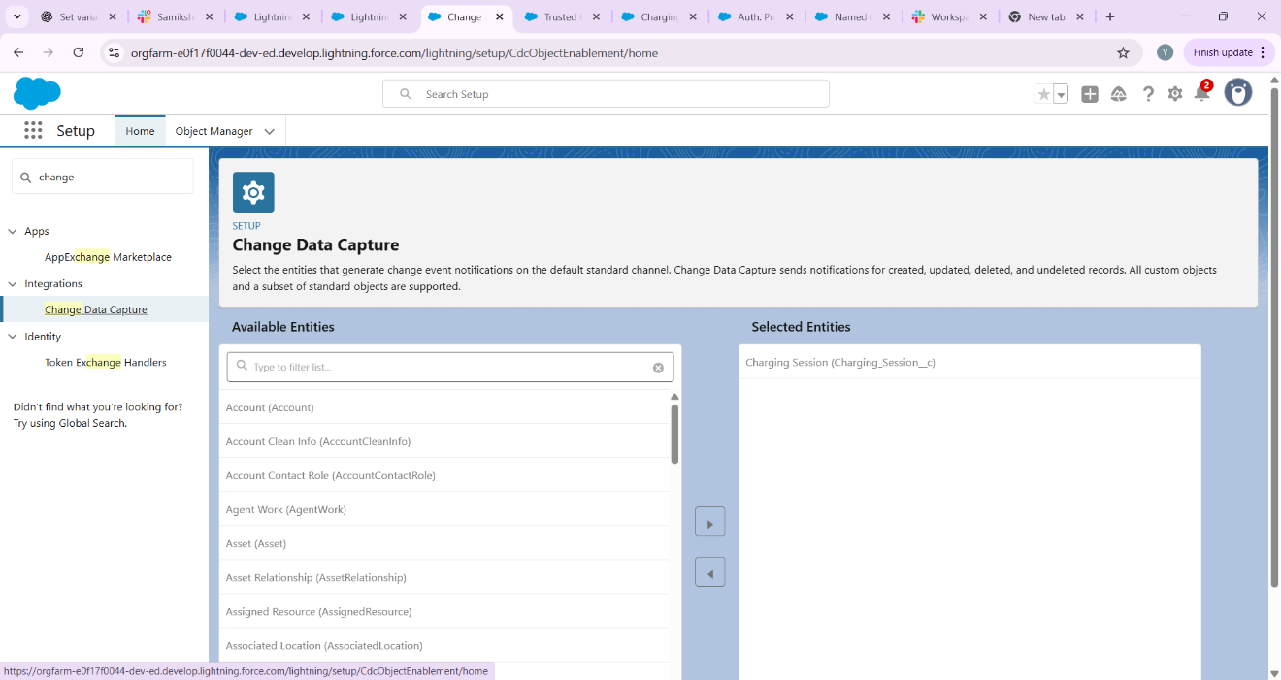

**Step 6: Salesforce Connect (Optional)**- Use Salesforce Connect to access external objects if EV stations data is outside Salesforce.  
  
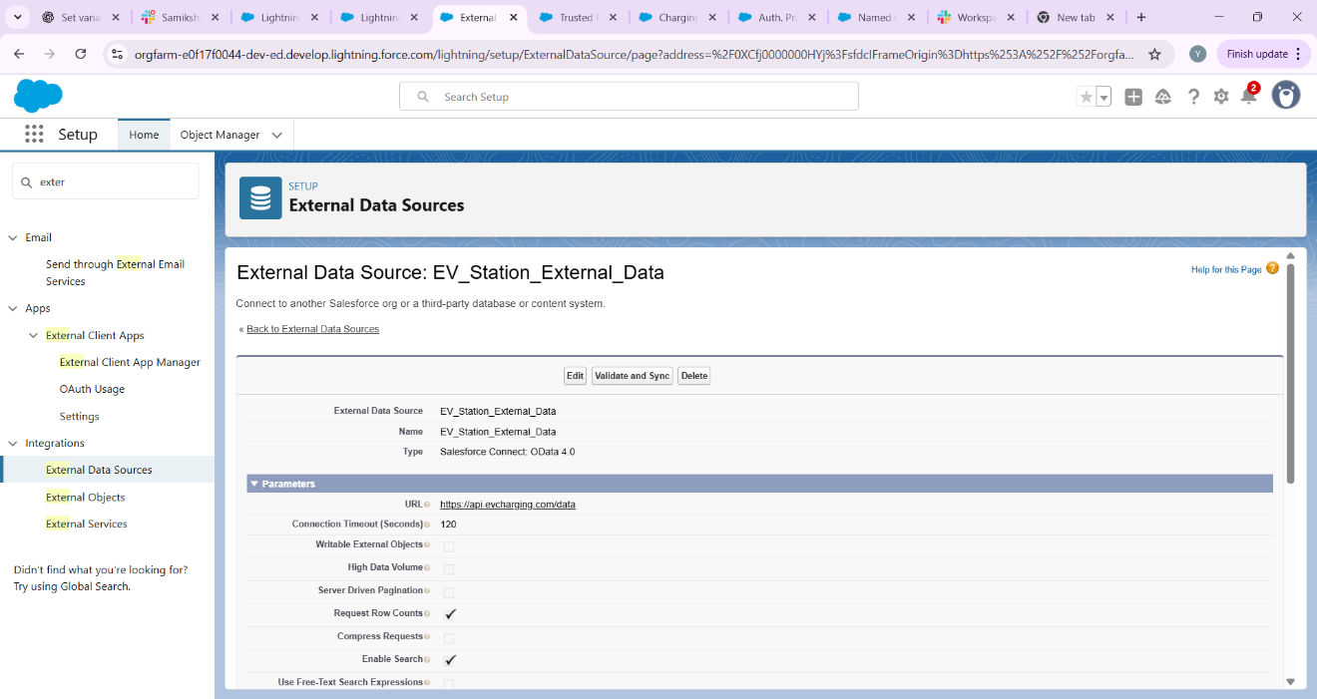

**Step 7: API Limits, OAuth, Remote Site Settings**1. Setup → API Usage Notifications → Monitor API calls.  
2. Setup → Remote Site Settings → Add external API endpoints if not using Named Credential.  
3. Setup → Connected Apps / OAuth → For external system login.

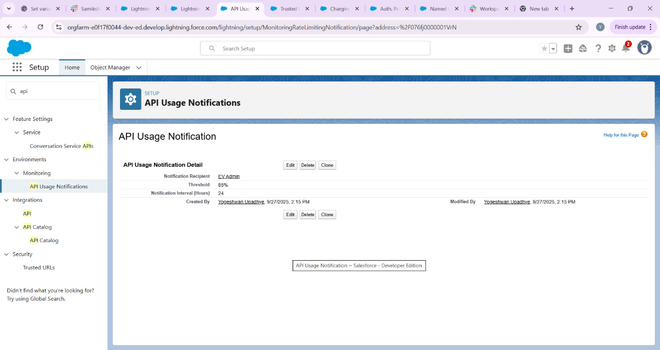

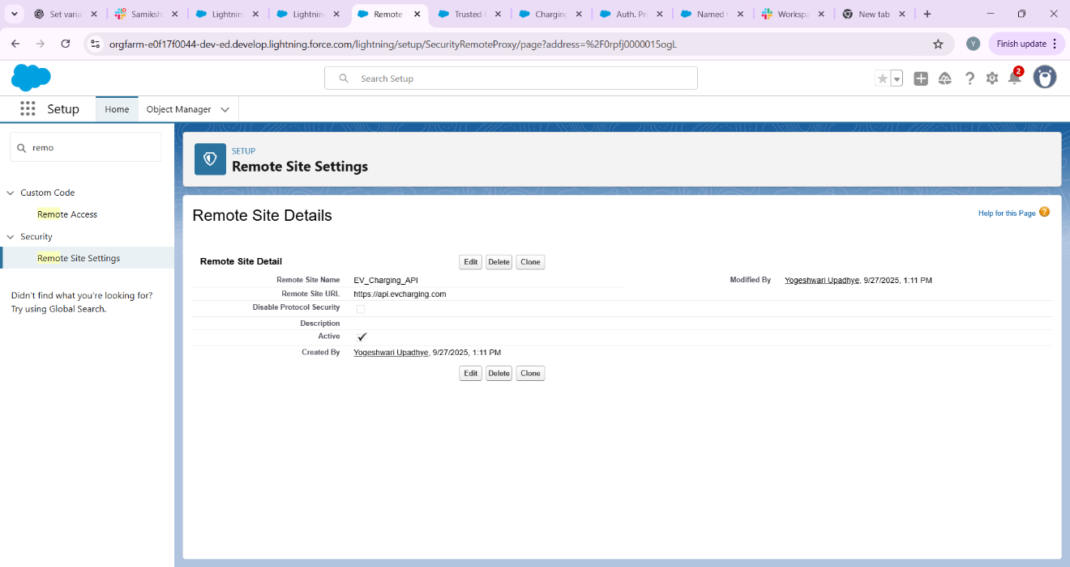

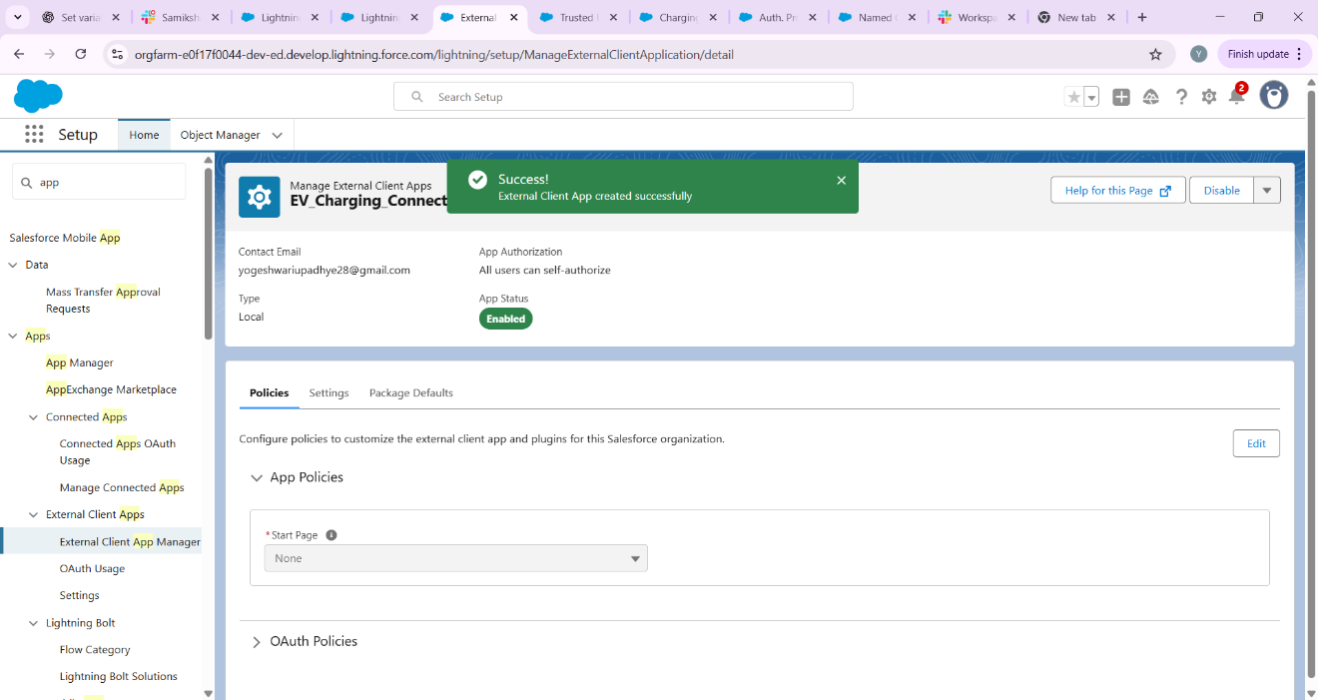

**Future Enhancements**  
- Link UI components (Screen Flow / LWC) to trigger external API calls.  
- Add Apex triggers for advanced validation once Phase 5 is completed.  
- Use async processing for batch updates.

Top of Form

Bottom of Form

**Phase 8: Data Management & Deployment for EV Charging CRM**

Goal: Manage data efficiently and move configurations from Sandbox to Production.

**1. Data Import Wizard**

Import 50 demo Charging Station records.

Import 50 demo EV Charging Session records.

Steps:

1. Go to Setup → Data → Data Import Wizard.

2. Select object: Charging Station / Charging Session.

3. Upload CSV files.

4. Map fields and start import.

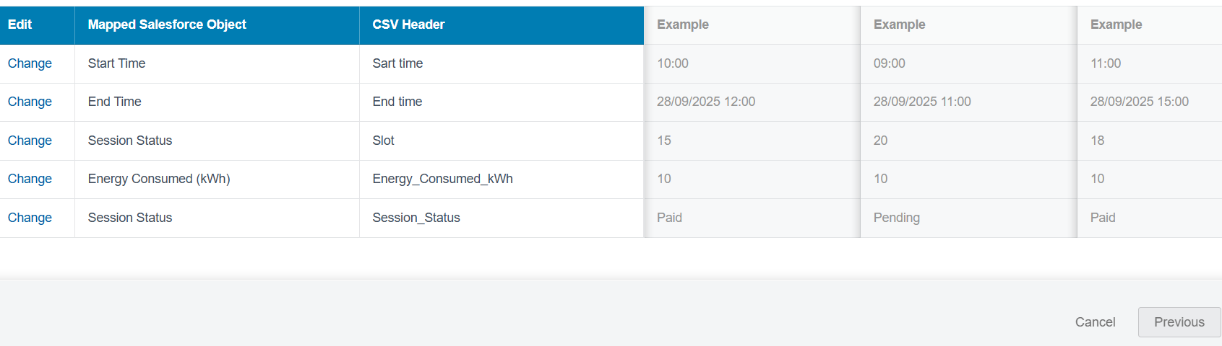

**2. Data Loader**

Bulk import Bookings, Users, and Payment records.

Steps:

1. Open Data Loader → Insert.

2. Select object: Booking / User / Payment.

3. Browse CSV file.

4. Map fields and click Finish.

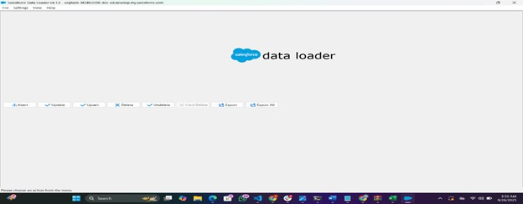

**3. Duplicate Rules**

Prevent duplicate Charging Station entries.

Steps:

1. Setup → Duplicate Rules.

2. Create new rule for Charging Station object.

3. Define matching criteria (e.g., Station Name + Location).

4. Activate rule.

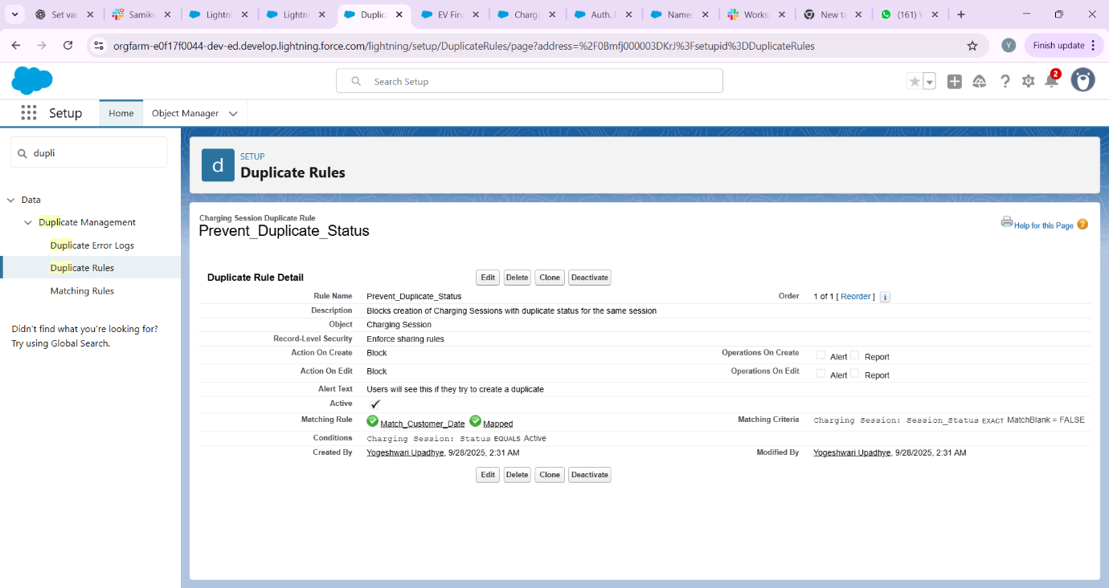

**4. Data Export & Backup**

Weekly backup of all CRM data.

Steps:

1. Setup → Data → Data Export.

2. Schedule export weekly.

3. Download exported files and save securely.

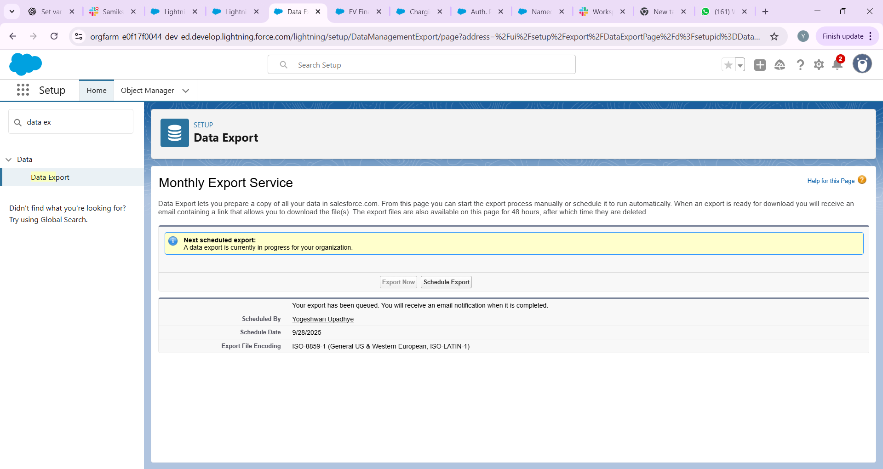

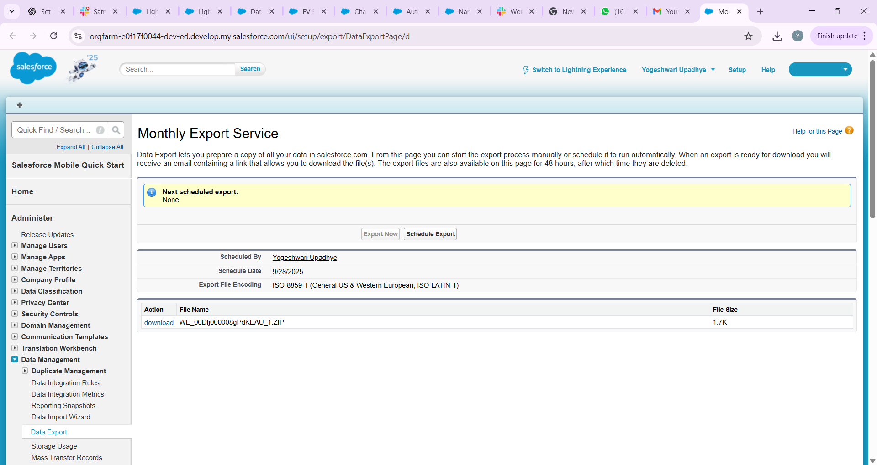

**5. Change Sets**

**Purpose:** Move metadata/configurations from **Sandbox → Production** safely.

**Steps:**

1. Setup → **Outbound Change Sets**.
2. Click **New** → Give a name (e.g., EV_Charging_Release_1).
3. Add **Components**: Objects, Fields, Flows, Validation Rules, etc.
4. Click **Upload** → Select the **Production org**.
5. Login to Production → **Inbound Change Sets** → Review → Deploy.

**Use Case:**

* Deploy your **Charging_Session__c object, flows, and validation rules** from Sandbox to Production without manual re-creation.

**6: Unmanaged vs Managed Packages**

**Purpose:** Package your Salesforce configurations for deployment or distribution.

**Details:**

* **Managed Package:** For publishing on **AppExchange**. Adds versioning and protection.
* **Unmanaged Package:** For **internal deployment** within your org.

**Use Case:**

* If you want your **EV Charging CRM app** for internal testing across multiple orgs → use **Unmanaged Package**.
* If you plan to **sell or share publicly** → use **Managed Package**.

**7. ANT Migration Tool**

**Purpose:** Command-line deployment for bulk metadata migration between Salesforce orgs.

**Steps:**

1. Configure **build.xml** and **package.xml** with metadata components.
2. Use commands:
   * ant retrieve → fetch metadata from source org
   * ant deploy → deploy to target org
   * ant validate → test deployment without committing
3. Review log files for success/failures.

**Use Case:**

* Move **multiple objects, flows, and validation rules** from Sandbox → Production efficiently, especially for large orgs.

# **EV Charging CRM Project – Phase 9: Reporting, Dashboards & Security Review**

## Objective

Monitor business operations, measure performance, and secure data access for the EV Charging CRM. This phase builds reports and dashboards for stakeholders and configures sharing and security settings to protect sensitive information.

## **1. Reports**

Create the following reports to monitor key metrics and operations:

### Charging Station Utilization

Purpose: Show how many sessions and total charging units per station over a period.  
Steps:  
1. Go to Reports → New Report.  
2. Select report type: Charging Sessions (or a custom report type combining Charging Session and Charging Station).  
3. Add filters: Date range = Last 30 days (or custom), Status = Completed.  
4. Group rows by Charging Station Name.  
5. Columns: Count of Session Id, Sum of Charging_Units__c, Sum of Total_Amount__c.  
6. Add chart: Column or Stacked Column. Save as 'Charging Station Utilization'.

### Revenue by Station (or by Station Type)

Purpose: Shows revenue collected per station or station model.  
Steps:  
1. New Report → Charging Sessions.  
2. Filters: Date range, Payment Status = Paid.  
3. Group by Charging Station Name or Station Model.  
4. Columns: Sum of Total_Amount__c.  
5. Add chart: Pie or Donut for share, or Bar for comparison. Save as 'Revenue by Station'.

### Energy Consumption by Day

Purpose: Daily kWh consumption trend to identify peak usage times.  
Steps:  
1. New Report → Charging Sessions.  
2. Filters: Date range = Last 30 days.  
3. Group by Start Date (calendar day) or use a row-level formula to extract day.  
4. Columns: Sum of Charging_Units__c.  
5. Add a Line Chart. Save as 'Energy Consumption by Day'.

### Top Customers by Revenue

Purpose: Identify customers contributing most revenue.  
Steps:  
1. New Report → Charging Sessions with Customer.  
2. Filters: Payment Status = Paid, Date range as needed.  
3. Group by Customer Name.  
4. Columns: Sum of Total_Amount__c. Add Top N filter to show top 10. Save as 'Top Customers by Revenue'.

### Payment Status Summary

Purpose: Quick status of payments (Paid, Pending, Failed) for reconciliation.  
Steps:  
1. New Report → Charging Sessions.  
2. Group by Payment_Status__c.  
3. Columns: Count of sessions and Sum of Total_Amount__c. Save as 'Payment Status Summary'.

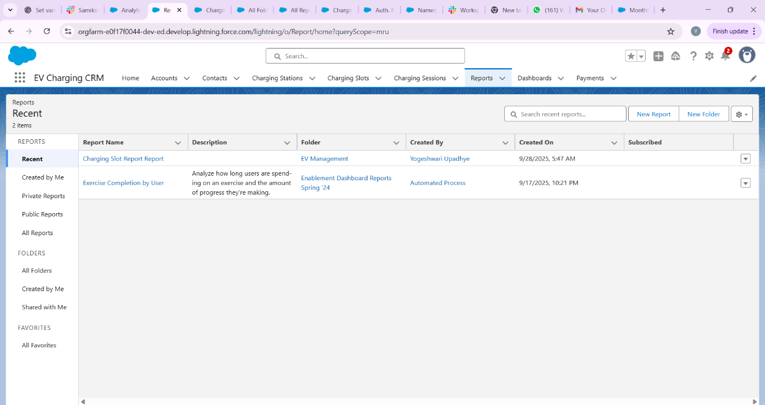

## **2. Report Types**

If you need combinations of objects (for example, Charging Session with Charging Station or Charging Session with Customer), create a Custom Report Type:

Steps:  
1. Setup → Report Types → New Custom Report Type.  
2. Primary Object: Charging_Session__c.  
3. Related Object: Charging_Station__c (if you want station fields) or Contact/Account for customer fields.  
4. Define the relationship (Each "A" record must have at least one related "B" record or optionally include records without related items).  
5. Deploy the report type and use it when creating reports to access fields from both objects.

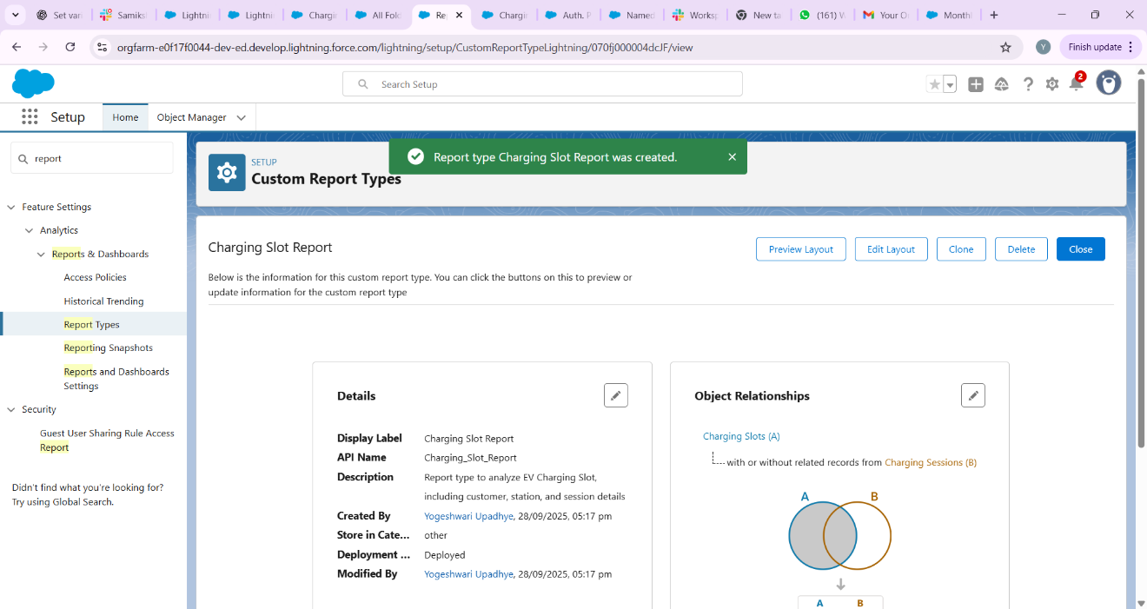

## **3. Dashboards**

Dashboards combine reports into visual components for stakeholders. Create a few dashboards:

### Operations Overview Dashboard

Components: Energy Consumption by Day (Line), Charging Station Utilization (Bar), Payment Status Summary (Donut), Metric widgets for Today’s Sessions and Today’s Revenue.  
Audience: Operations team.

### Manager Revenue Dashboard

Components: Revenue by Station (Bar), Top Customers by Revenue (Table), Revenue trend (Line), Monthly revenue metric.  
Audience: Finance / Managers.

### Station Performance Dashboard

Components: Per-station charts and tables, station uptime metrics, average session duration.  
Audience: Field / Station managers.

### Dashboard Creation Steps

1. App Launcher → Dashboards → New Dashboard.  
   2. Enter Name (e.g., Operations Overview), Folder (access control), and select a running user (or make it dynamic).  
   3. Add components by selecting the report and choosing visualization types (chart, table, gauge, metric).  
   4. Configure component properties: grouping, X/Y axes, number formatting, thresholds for gauges.  
   5. Save and run the dashboard. Share the dashboard folder with relevant users and groups.

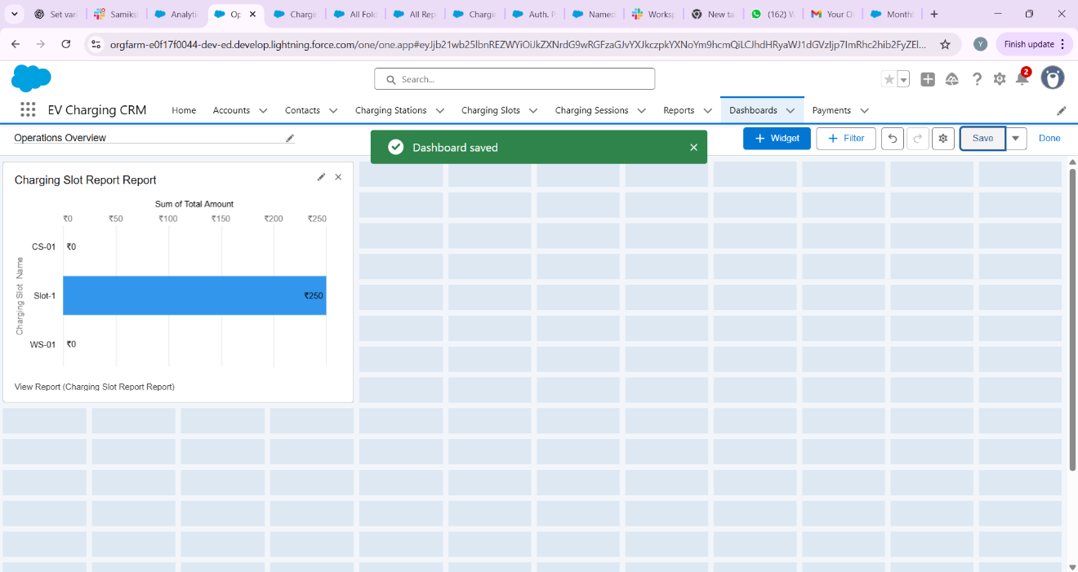

## 4. Dynamic Dashboards

Dynamic dashboards allow the dashboard to run as the logged-in user so each viewer sees data they are permitted to view (row-level security applied).

Steps:  
1. Edit a dashboard → Click "View Dashboard As" → Choose "The dashboard viewer".  
2. Note: Salesforce has limits on the number of dynamic dashboards per org; check org limits in Setup → Reports and Dashboards Settings.  
3. Use dynamic dashboards for manager views or agents who should only see their own bookings/sessions.



## **5. Sharing Settings**

Configure Org-Wide Defaults and Sharing Rules to control record visibility:

Recommended settings for EV Charging CRM:

- Charging_Session__c: Private (only owner and shared users can see).

- Charging_Station__c: Public Read Only or Private if stations contain sensitive info.

- Customer/Contact: Private or Controlled by Parent depending on business needs.

Steps to configure:

1. Setup → Security → Sharing Settings.  
   2. Set Organization-Wide Defaults for each object as above.  
   3. Create Public Groups or Roles (e.g., Operations Team, Managers).  
   4. Create Sharing Rules: e.g., share Charging_Session__c to Managers group where Station region = X.  
   5. Use Apex sharing or manual share when complex rules are required.

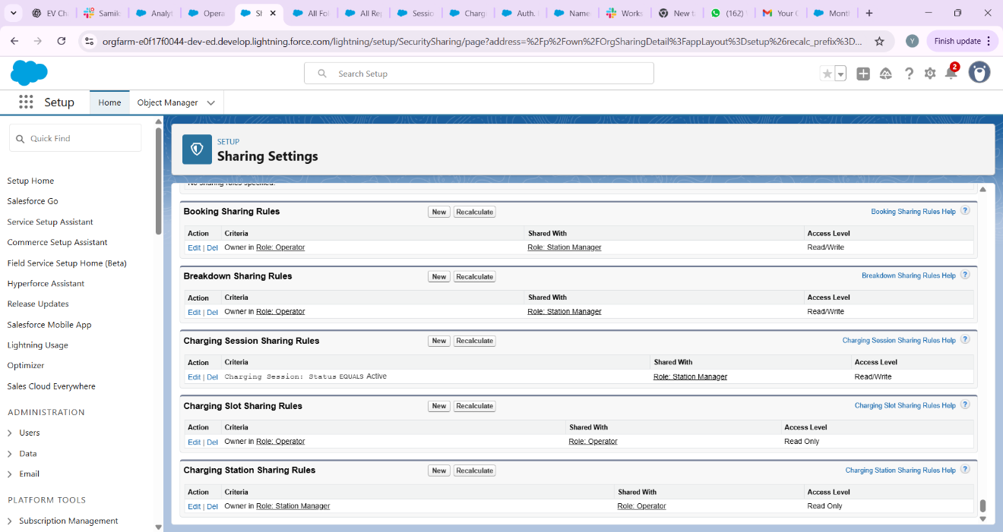

## **6. Field Level Security**

Protect sensitive fields by configuring Field-Level Security and Page Layouts. Example: Hide Customer ID Proof field from agents:

Steps:  
1. Setup → Object Manager → Charging_Session__c → Fields & Relationships.  
2. Click the sensitive field (e.g., Customer_ID_Proof__c) → Set Field-Level Security.  
3. Uncheck visibility for Agent profile(s) and ensure System Administrator and Managers have access.  
4. Additionally remove the field from page layouts for profiles that should not see it.

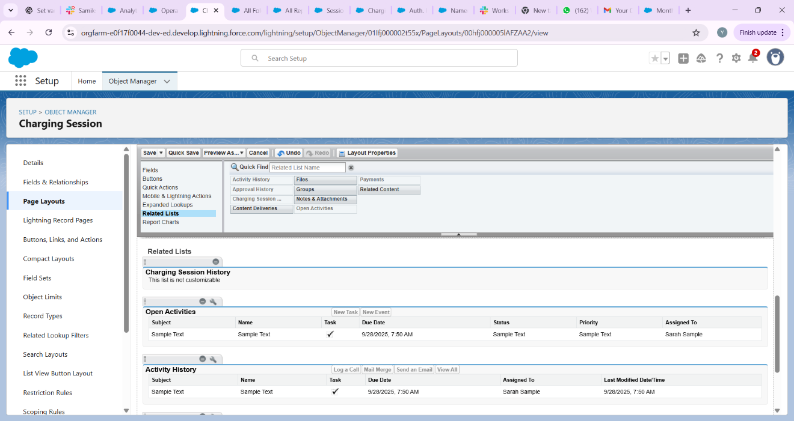

## **7. Session Settings**

Configure user session timeout and security settings:

Steps:  
1. Setup → Security → Session Settings.  
2. Set Session Timeout to 30 minutes (or organization standard).  
3. Configure additional settings like Force logout on session timeout if required.

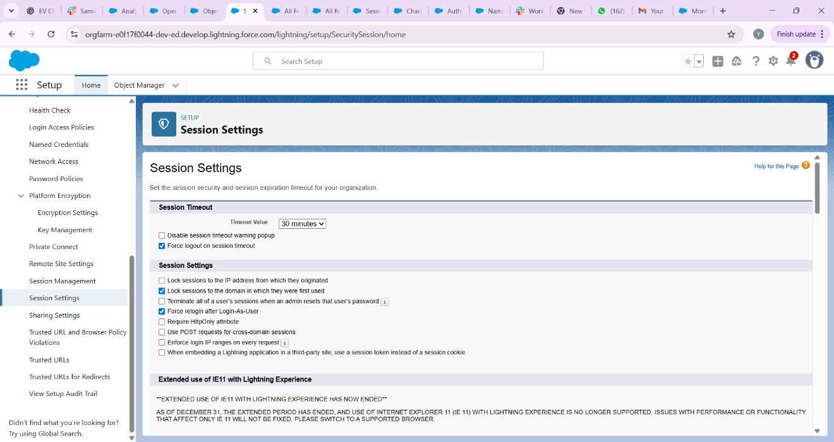

## **8. Login IP Ranges**

Restrict access for certain profiles to internal office networks if needed:

Steps:  
1. Setup → Users → Profiles → Select profile (e.g., Agent).  
2. Under Login IP Ranges → Add IP range for office (e.g., 203.0.113.0 to 203.0.113.255).  
3. Save. Users in that profile can only login from allowed IPs.

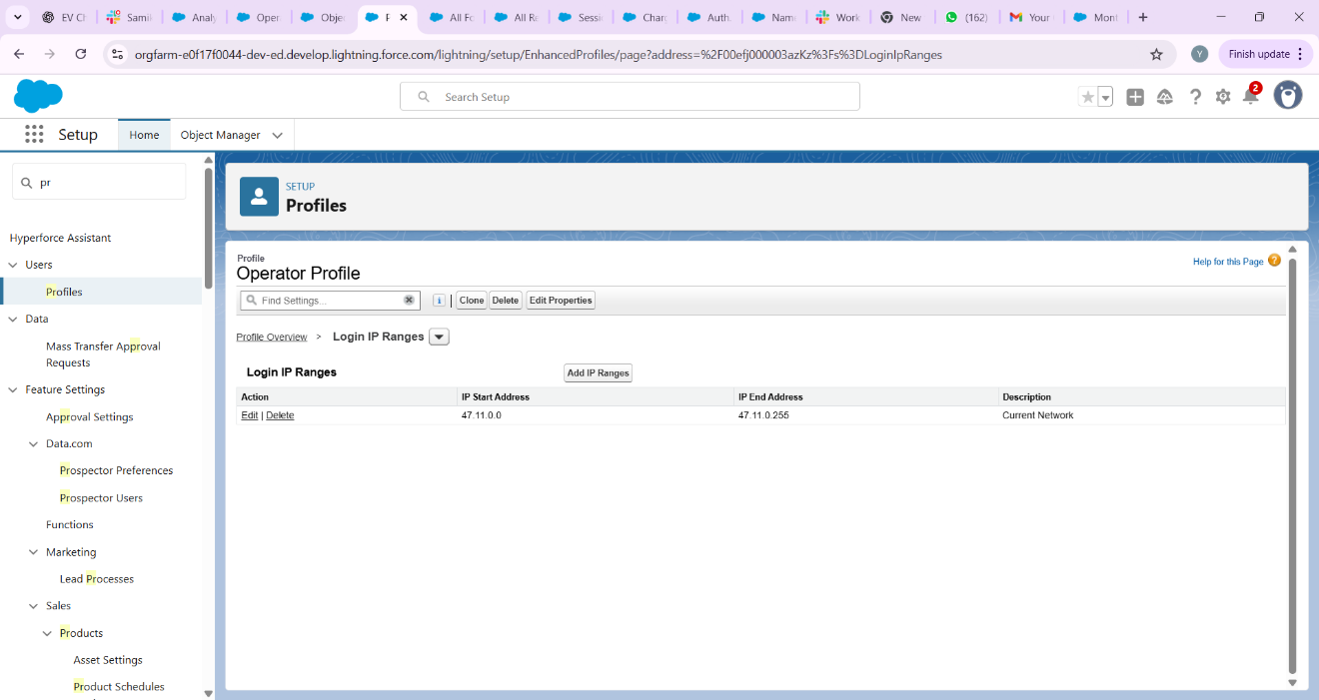

## **9. Audit Trail & Field History Tracking**

Enable tracking to record configuration changes and data changes:

Setup Audit Trail:

1. Setup → View Setup Audit Trail. This shows recent setup changes for 180 days that you can download.

Field History Tracking:

1. Setup → Object Manager → Charging_Session__c → Fields & Relationships.  
   2. Click Set History Tracking → Select fields to track (e.g., Status, Payment_Status__c, Total_Amount__c).  
   3. Save.  
   4. Add the "History" related list to the Charging Session page layout to view changes.

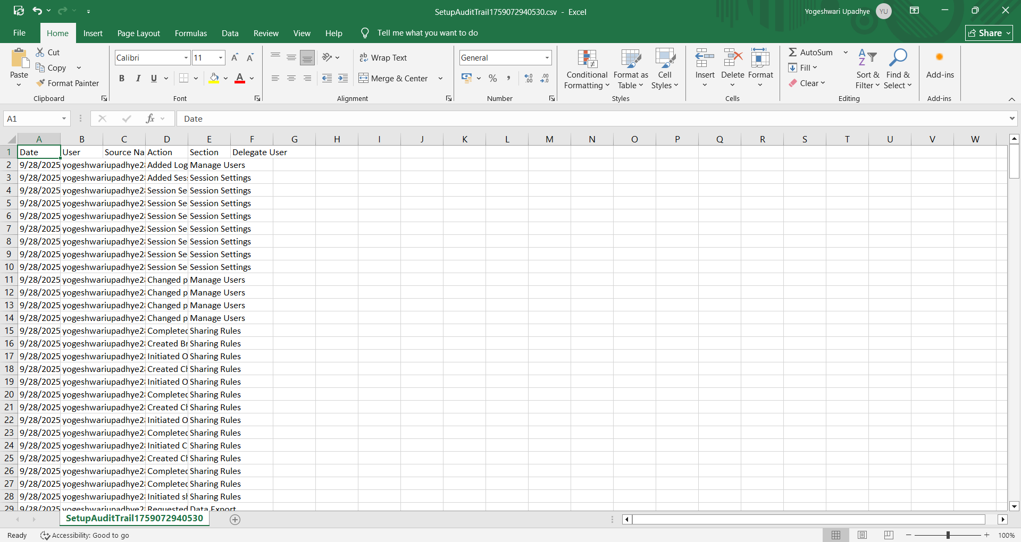

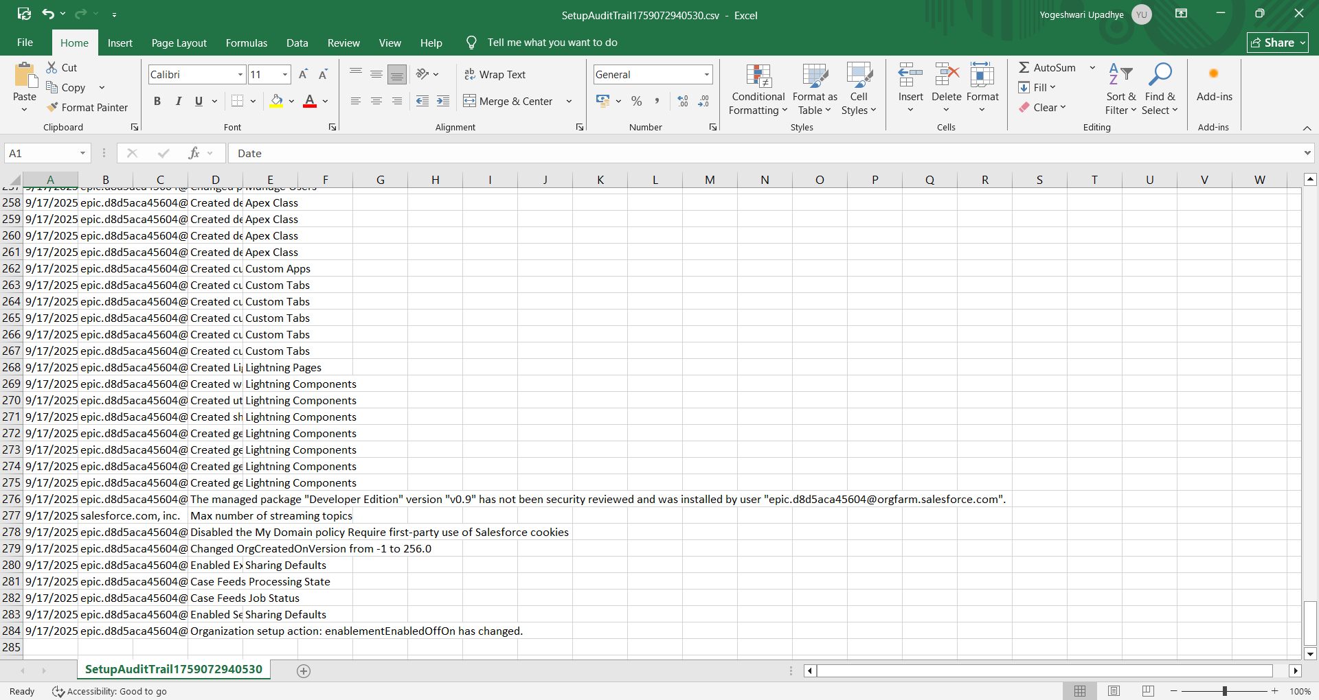

## Conclusion

Phase 9 ensures that stakeholders have visibility into operations and revenue, while enforcing appropriate security controls. Implementing the reports, dashboards, and security measures outlined above will provide a robust monitoring and governance layer for the EV Charging CRM.

**This is the demo video link**

https://drive.google.com/file/d/11-0_5Q_oLgiH9MIaQbuQK0DYzFjJrz3U/view?usp=drivesdkhttps://drive.google.com/file/d/11-0_5Q_oLgiH9MIaQbuQK0DYzFjJrz3U/view?usp=drivesdk